Dawley C of E Primary
Academy

Enriching Learning, Enriching Life’

John 10:10 ‘…I have come that they may have life, and have it to the full.’

Dawley Academy Home Learning Policy
In response to COVID-19

Vision

‘I have come that they may have life, and have it to the full. John 10:10

Our vision is to develop flourishing, caring children, equipping them with the skills to reach their potential. We believe in a curriculum that enriches lives, ignites interests, and engages children in real-life experience, as global citizens with an inclusive respect for others, readying them for their future, to live life to the full.

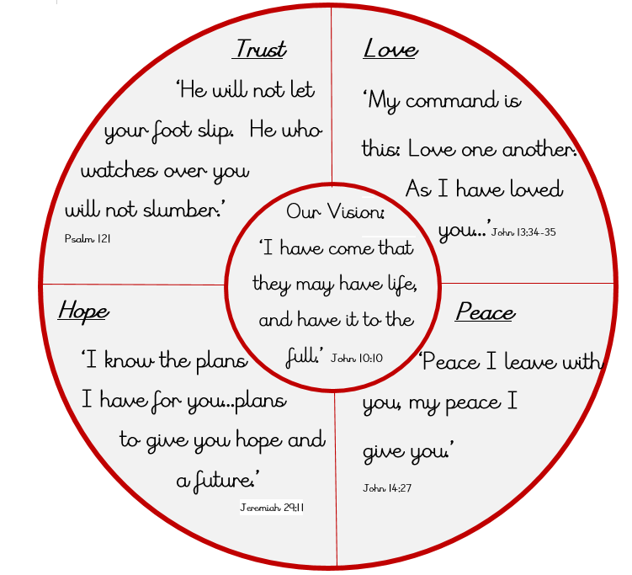

DATE WRITTEN : 31.3.2020
DATE SHARED WITH STAFF:-31.3.2020

CONTEXT
From 20th March 2020 parents were asked to keep their children at home, wherever possible, and for schools to remain open only for those children of workers critical to the COVID-19 response - who absolutely need to attend.

During this academy closure, Dawley Academy, has provided access to work for pupils to continue and consolidate their learning at home.

Dawley Academy uses Purple Mash as an interactive learning platform. This is a safe site where pupils can navigate around without any pop ups, or links to activities out of the site. Each class, from Nursery to Year 6, will have 2Do activities set by the class teacher, which can be monitored and marked by staff. This interaction with our pupils is essential contact to continue their learning and communication with staff. All pupils have used Purple Mash in their learning so are familiar with the resources.

Website and activity links will be added to our Academy website for each year group to explore. These links will be checked by staff before they are added to the website, and we encourage parent support when monitoring their children online. There are a range of online safety activities and links for both pupils and parents to access for support. There are links to creating a family agreement for internet access, screen time and using online learning responsibly, we encourage parents to access these when necessary. All pupils know what to do when faced with something they do not like on the internet and are able to report this to their adults at home or through our CEOPs link on our academy website. Our online safety work will continue during the academy closure, through 2Do activities on Purple Mash, set by staff at an appropriate level. Links to the parent activity packs, created by thinkuknow.com, will be accessible from the academy website fortnightly.

Home learning activity packs will be printed and sent out to all pupils who do not have access to the internet at home. If additional home learning packs are required, parents will contact the academy by phone or email to request them. All pupils have their own reading books, which they are encouraged to read at home with their parents/carers.

We encourage our families to spend time together during this unprecedented time and access learning when pupils are ready and keen.

