1. She Was a Child Prodigy
Born on February 21, 1933 in North Carolina, Simone came from a huge family; she was the sixth of eight children. Yet even from this tender age, it was clear Simone would stand out. She had an innate sense of music, started playing piano at her local church, and had her first classical recital at age 12. Only, Simone had to learn rebel from a young age, too…
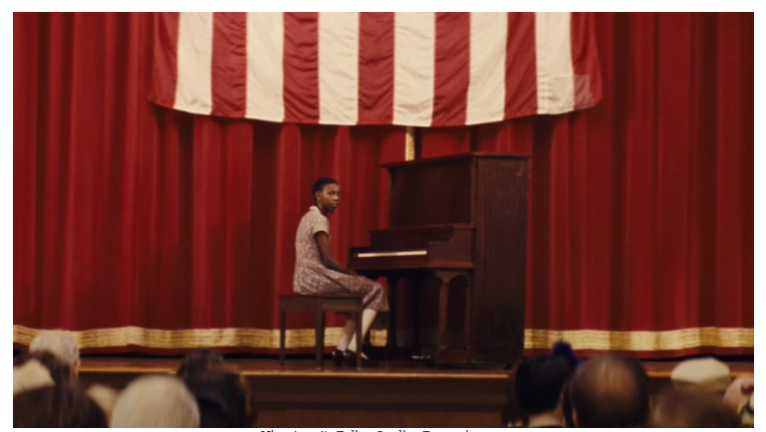

2. She Was a Rebel
When Simone staged her first concert as a pre-teen, it almost turned into an utter disaster. Her parents had come to the front row to watch their daughter play—only to have organizers force them into the back to make way for white people. Simone’s response was legendary. The precocious girl refused to play a note until her parents went to their rightful place.

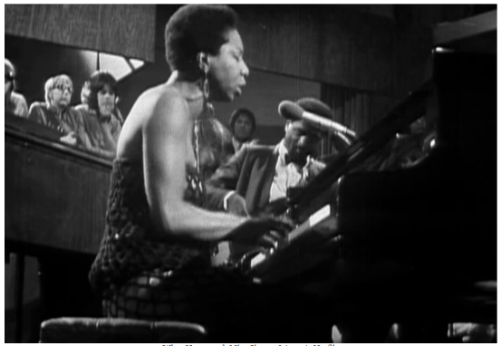
3. She Had a Strange Stage Presence
Early on in her career, Simone’s stage presence was both intimidating and mysterious, and she often seemed haughtily removed from her audience. After all, she was used to performing classical piano music for a hushed, reverential room. This same haughtiness helped earn her the nickname “The High Priestess of Soul”.

4. She Was Classically Trained
Simone’s music career started fast and furious, and people took major notice immediately. She spent the summer after her graduation at none other than Juilliard training with the legendary pianist Carl Friedberg.

5. She Suffered a Brutal Rejection
Simone reportedly nailed her audition for the institute—in fact, her family was so confident, they even moved down to Philadelphia. So when she got rejected, the blow was beyond devastating. Not only did Simone believe the denial came from racial prejudice, she also couldn’t even reapply, since Curtis didn’t accept incoming students over 21. But when one door closes, another one opens.

6. She Had a Twist of Fate
Although she was on the verge of giving up her dreams, Simone started taking private lessons in the piano and even “stooped” to play in nightclubs. This is where everything changed. To save costs, the nightclub owner demanded she also sing her own accompaniment, forcing Simone to use her voice, and birthing an icon in the process.

7. She Lied About Her Name
Simone’s nightclub work would have scandalized her parents, so she came up with a sneaky solution: Her now-legendary stage name. Originally born Eunice Kathleen Waymon, Simone picked the name “Nina” because of her boyfriend’s nickname for her, and “Simone” after the French actress Simone Signoret. As “Nina Simone,” she could play undetected.

8. She was Married
In 1958, all-consuming love came for Simone and left her ravaged. That year, she met and then married white fairground worker Don Ross when she was still just 25 years old. Ross was something of a hanger-on, and almost immediately after tying the knot, Simone regretted her decision. The couple split up shortly after saying their vows.

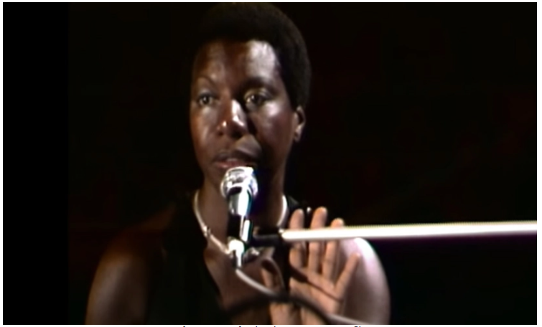
9. She Sold Out
In 1959, Simone put out her debut album…and made her first huge career mistake. Her album Little Girl Blue became a sensation, but Simone had huge contempt for its more mainstream material, and she actually sold the rights to the record label for a paltry sum that lost her over a million dollars in royalties.

10. She Raised Her Voice
During this period of her life, Simone plunged headfirst into the Civil Rights movement, counting among her friends luminaries like Malcolm X and poet Langston Hughes. At almost every Black moment of civil triumph, Simone was there—she even marched during the Selma to Montgomery protests.

11. The Industry Turned on Her
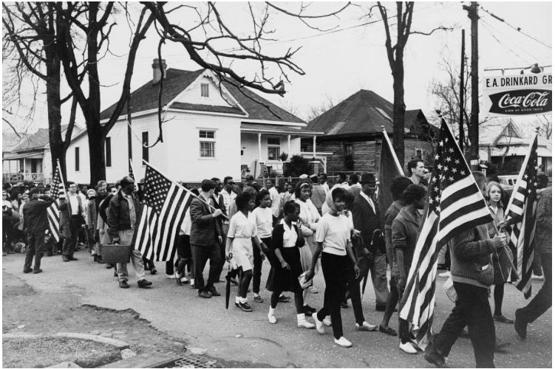
By the 1970s, Simone claimed her career suffered brutal setbacks because of her commitments to justice, and said no one would take her calls anymore, much less let her perform music. Consumed with hurt and anger, Simone decided to leave the US and set up in Barbados without telling almost anyone.

12. She Went out on Her Own Terms
By the early 2000s, Simone’s health was failing and her body was crumbling; everybody knew she was fading away from breast cancer. True to herself until the end, Simone refused to return to America to face the end, or even go to the hospital. On April 21, 2003, she passed in her sleep at home in Carry-le-Rouet in France, leaving an entire generation in her wake.

