Our science topic this half term is Animals including humans.

Have a look at the PowerPoint and with your grownup discuss the different classes of animals.
Next, can you try sorting animals into their different classifications?

Cut out and stick, draw or write the animals and place them in the correct boxes. Look at the example below:
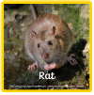
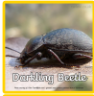
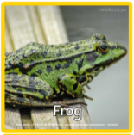
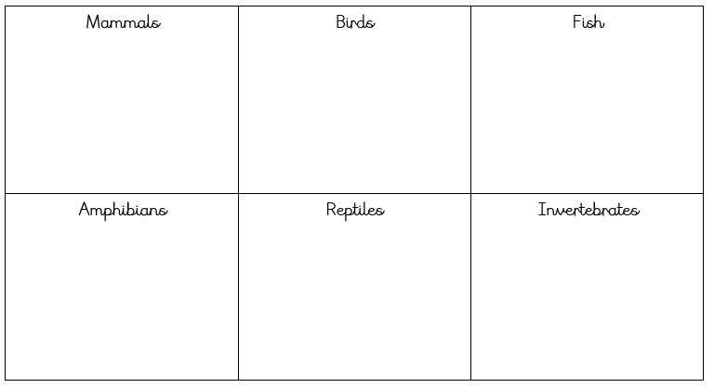

Mammals | Birds | Fish
Amphibians | Reptiles | Invertebrates

