Monday 2nd November 2020

Learning Context: Narrative

Learning Objective: To make predictions.

We need to work out what our new story is about using the clues that have been left behind.

Can you look at the clues and think about what our story this week could be?

Focus on 3 questions:

What? What has happened in the story?

Who? Who is the story about?

Where? Where is the story set?

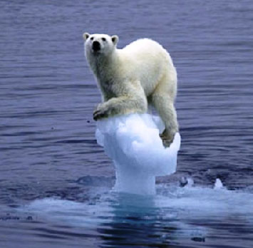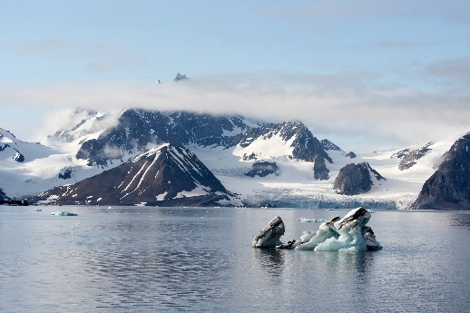Clue 1: Clue 2:

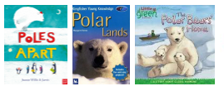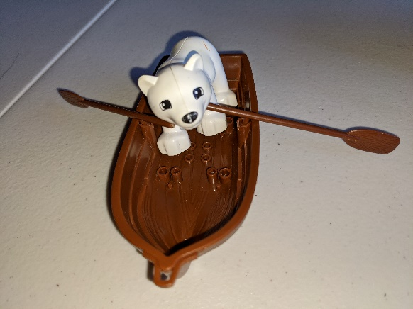

Clue 3: Clue 4:

Wednesday 4th November 2020

Learning Context: Narrative

Learning Objective: To make inferences

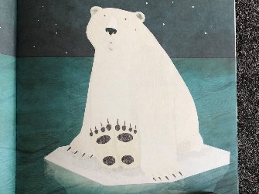Look at the illustration below.

How do you think the polar bear is feeling?

Where is the polar bear?

What clues can you find in the picture to help you answer the questions?

Can you write a sentence on how you think the polar bear is feeling and what might have happened to him?

For example:

I think the polar bear is feeling ………. because ………..

Remember to use capital letters, full stops and finger spaces.

Thursday 5th November 2020

Learning Context: Narrative

Learning Objective: To write a sentence

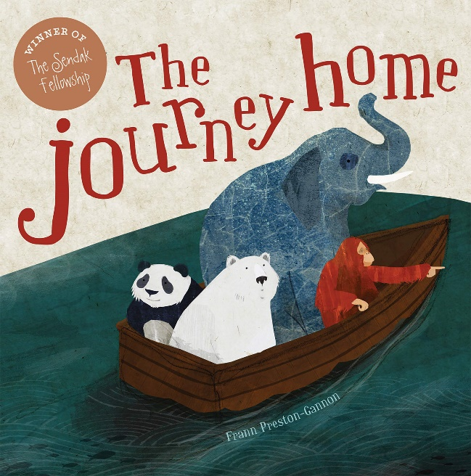Our story this week and next week is: The Journey Home by Frann Preston-Gannon.

If you do not have the story at home, you can watch it here:

<https://www.youtube.com/watch?v=-IsR3FR0ACo&t=28s>

After listening to the story talk about it to your grownups.

Where your prediction right?

What happened in the story?

How do you think the animals felt?

Now, can you write a short paragraph (2/3 sentences) on what happened in the story?

Don’t forget to use capital letters, full stops and finger spaces.

Friday 6th November 2020

Learning Context: SPAG

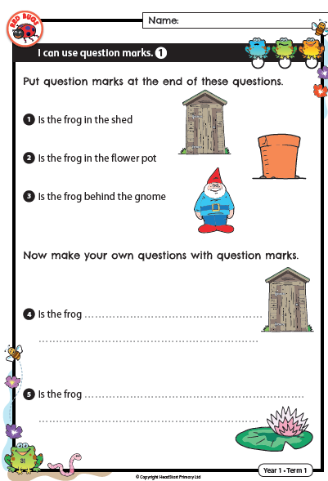Learning Objective: To use question marks

