Wednesday 3rd November 2020
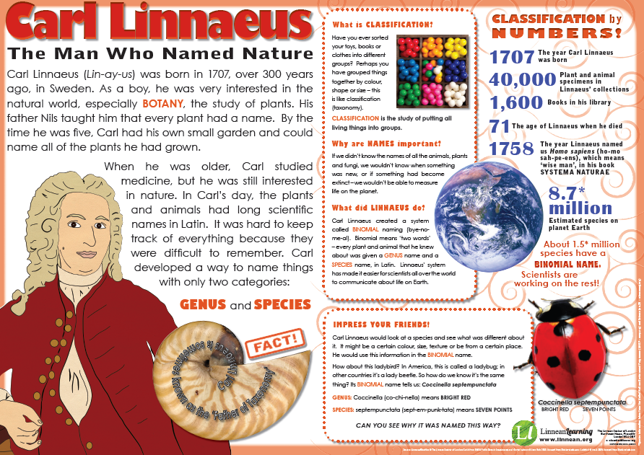
L.O. – To retrieve information from a non-fiction text.
PEA for all answers please!
- Who helped Carl develop his interest in living things?
- True or false – Carl went to university and got a degree in Natural Studies.
- Botany is all about going on a sea voyage to discover things. True or false?

Q – What is a binomial name?

