Circle the box with **the greatest** amount.

|  |  |  |  |  |  |  |
| --- | --- | --- | --- | --- | --- | --- |
| Image result for five pound clip art |  | Image result for ten pound clip art |  | http://resources.woodlands-junior.kent.sch.uk/customs/questions/images/money/5p.gifImage result for 50p clip art |  | Related imagehttp://america.pink/images/4/8/0/9/en/2-10p.jpgImage result for 50p clip art |

£____ £____ ____p ____p

|  |  |  |  |  |  |  |
| --- | --- | --- | --- | --- | --- | --- |
| Image result for five pound clip artImage result for five pound clip art |  | Image result for ten pound clip art  Image result for ten pound clip art |  | http://resources.woodlands-junior.kent.sch.uk/customs/questions/images/money/5p.gifImage result for 20p clip art |  | http://resources.woodlands-junior.kent.sch.uk/customs/questions/images/money/2p.gifhttp://resources.woodlands-junior.kent.sch.uk/customs/questions/images/money/2p.gifhttp://america.pink/images/4/8/0/9/en/2-10p.jpg |

£____ £____ ____p ____p

Circle who has **the least**?

I have £24 I have 24p I have 38p I have £38



Use **<**, **> =** to compare the amounts.

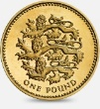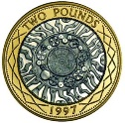

£____ £____

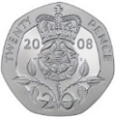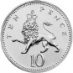

____p ____p

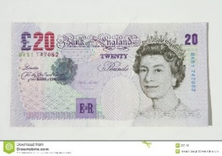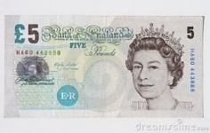

£____ £____

Four 5 pence coins are worth **more than** two 10 pence coins.

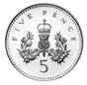

Do you agree? ____

Explain why