Date | Music relaxation | Activity | Resources/ WAGOLL
Week 4 | Samuel Barber - Adagio for Strings - YouTube | Ask the children to reflect on the work we did in the Autumn term surrounding equality. Children to discuss the problems faced by segregation in 1960s America and the activists fighting against it. Remind them that it was against the law for black and white people to marry in the 1960s.  Read the picture book ‘Mixed’ by Aree Chung or watch the video of Aree reading it here:  Storytime Video: Mixed by Arree Chung - YouTube  Discuss themes. Reflect on own families. Children to use watercolour to explore how to make different colours and then create their own diverse town in the style of Aree. | 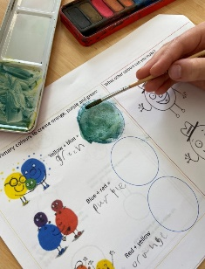  ‘Mixed’ by Aree Chung  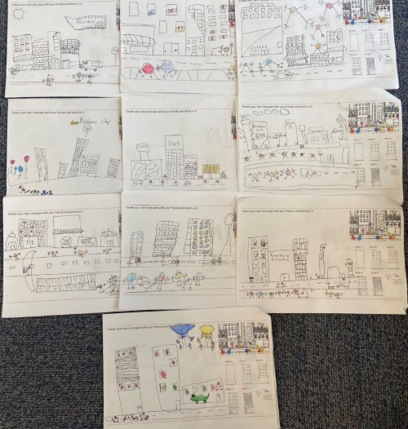  Template sheets

