Revision Slides 1
Day 1
Nouns  A noun names a person, place, idea, thing or feeling.  a boy  the cupboard  an owl  a mystery | Verbs  Verbs indicate doing, feeling or being.  Dursley blinked.  The cat waited.  They have a secret.  I wish!
Adjectives  An adjective describes a noun.  those strange noises  that mysterious letter  a cold, creepy feeling  The cloak was green. | Adverbs  Adverbs often modify verbs.  We fought hard against it.  They can also modify adjectives,  It had horribly sharp talons.  or a whole clause.  Then, it appeared with a shriek.
Prepositions  Prepositions link a noun or noun phrase to a sentence  We rowed to the island.  Owls hooted after dark.  In the morning, we arrived.  They tell us how words are related. | Determiners  Determiners stand in front of nouns.  They specify a noun.  a sound  his wand  that danger  The noun is still there.
Pronouns  Pronouns replace a noun or noun phrase.  They ran.  She knew.  The bus was theirs.  The letter was his.  The noun is not there. It is replaced. | Conjunctions  Co-ordinating join two words or clauses.  The man knocked and waited.  Subordinating introduce subordinate clauses.  He woke when the door burst open.

Word Class Grid
Day 1

- Choose at least 8 words from the grid. You must include words from each word class.
- Write a definition for each word, including stating the word class.
- If your word can fit into more than one class, write a definition for each meaning.
- If you have time, choose more words from the grid.

muggle | Hufflepuff | insult | those | deadly | her | 1) Noun  2) Verb  3) Adjective  4) Adverb  5) Preposition  6) Determiner  7) Pronoun  8) Conjunction
fast | curse | challenge | mysterious | powerful | howler | Voldemort
parchment | giant | fly | because | evil | owl | Ravenclaw
but | where | a | sorcerer | terrify | animagus | gamekeeper
Dumbledore | snitch | wizard | courageous | anxious | pensieve | Gryffindor
above | strangely | across | the | dare | witch | an
swoop | apparate | disapparate | silently | Slytherin | with | under
they | it | swiftly | she | them | chocolate | put-outer
when | Hogwarts | although | since | Quidditch | if | normal
magical | cast | perfectly | hide | suddenly | sadly | mysteriously
hard | below | terrifyingly | rapidly | he | furiously | rose

Synopsis Extract
Day 2

Harry Potter lives with his aunt, uncle and cousin because his parents died in a car-crash — or so he has been told. The Dursleys don't like Harry asking questions; in fact, they don't seem to like anything about him, especially the very odd things that keep happening around him (which Harry himself can't explain).
The Dursleys' greatest fear is that Harry will discover the truth about himself, so when letters start arriving for him near his eleventh birthday, he isn't allowed to read them. However, the Dursleys aren't dealing with an ordinary postman, and at midnight on Harry's birthday the gigantic Rubeus Hagrid breaks down the door to make sure Harry gets to read his post at last. Ignoring the horrified Dursleys, Hagrid informs Harry that he is a wizard, and the letter he gives Harry explains that he is expected at Hogwarts School of Witchcraft and Wizardry in a month's time.
To the Dursleys' fury, Hagrid also reveals the truth about Harry's past. Harry did not receive the scar on his forehead in a car-crash; it is really the mark of the great dark sorcerer Voldemort, who killed Harry's mother and father but mysteriously couldn't kill him, even though he was a baby at the time. Harry is famous among the witches and wizards who live in secret all over the country because Harry's miraculous survival marked Voldemort's downfall.
So Harry, who has never had friends or family worth the name, sets off for a new life in the wizarding world. He takes a trip to London with Hagrid to buy his Hogwarts equipment (robes, wand, cauldron, beginners' draft and potion kit) and shortly afterwards, sets off for Hogwarts from Kings Cross Station (platform nine and three quarters) to follow in his parents' footsteps.
Harry makes friends with Ronald Weasley (sixth in his family to go to Hogwarts and tired of having to use second-hand spellbooks) and Hermione Granger (cleverest girl in the year and the only person in the class to know all the uses of dragon's blood). Together, they have their first lessons in magic — astronomy up on the tallest tower at two in the morning, herbology out in the greenhouses where the…

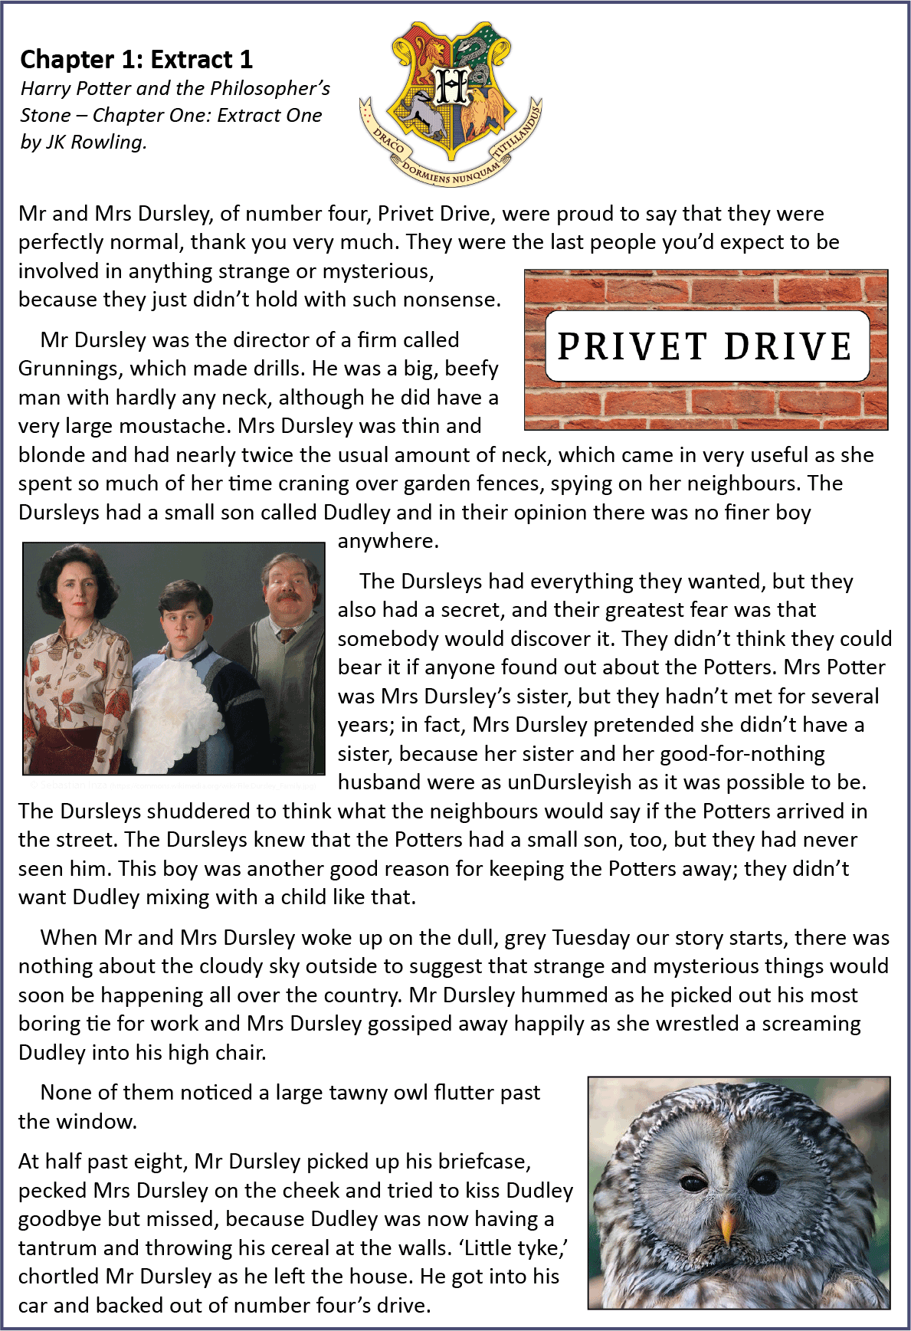
Day 2
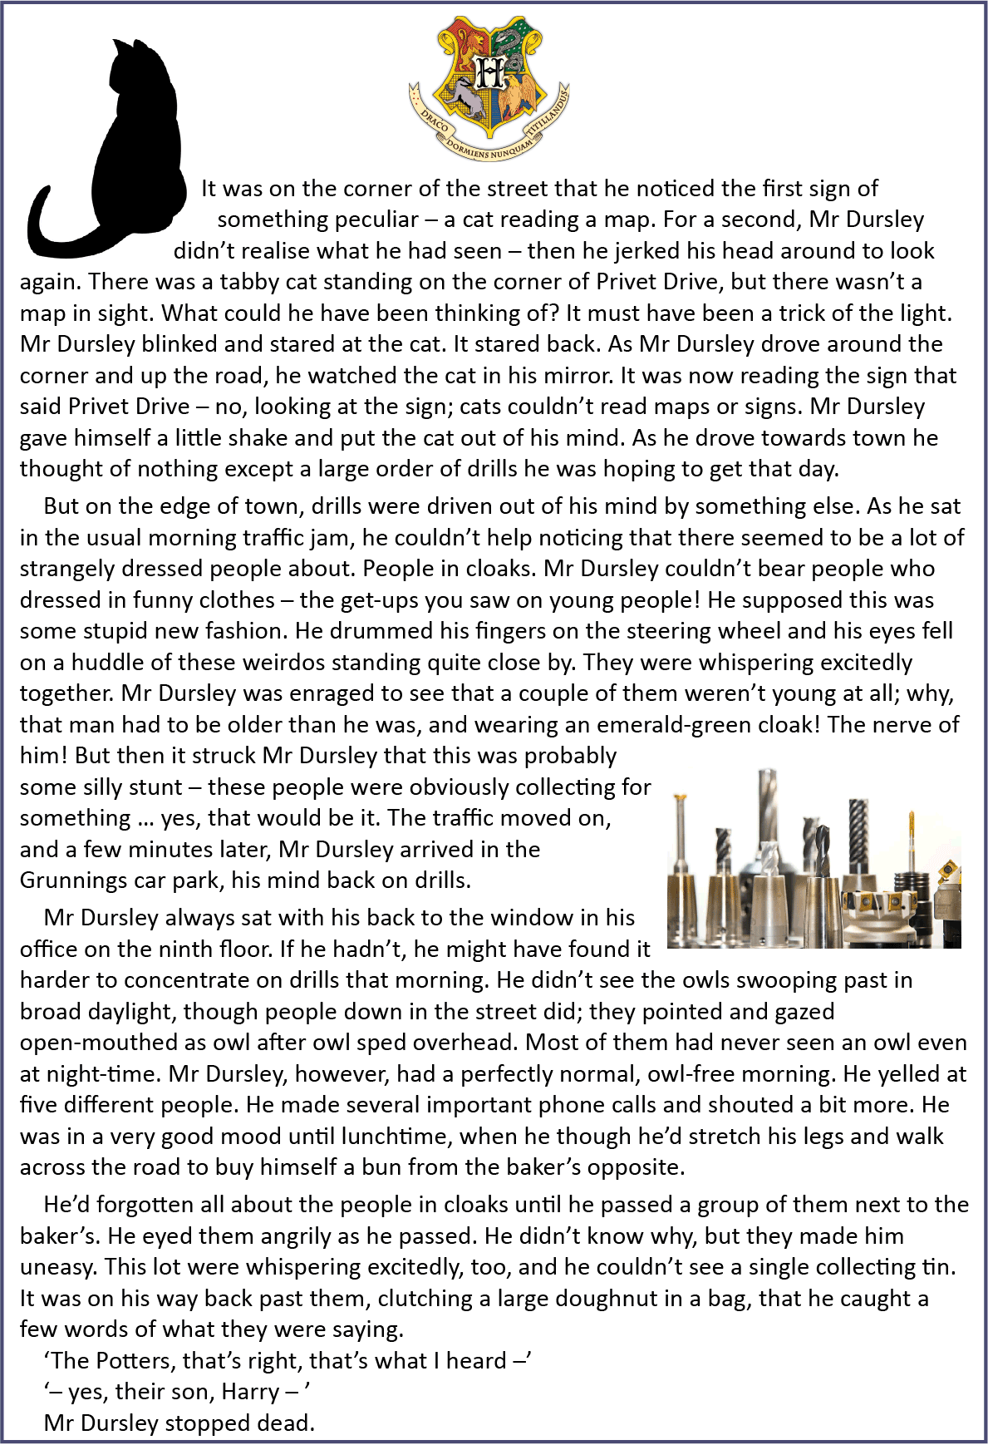
Revision Slides 2
Day 3
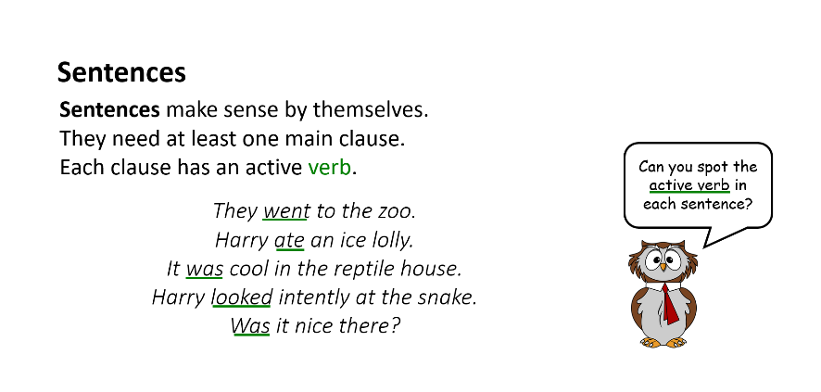
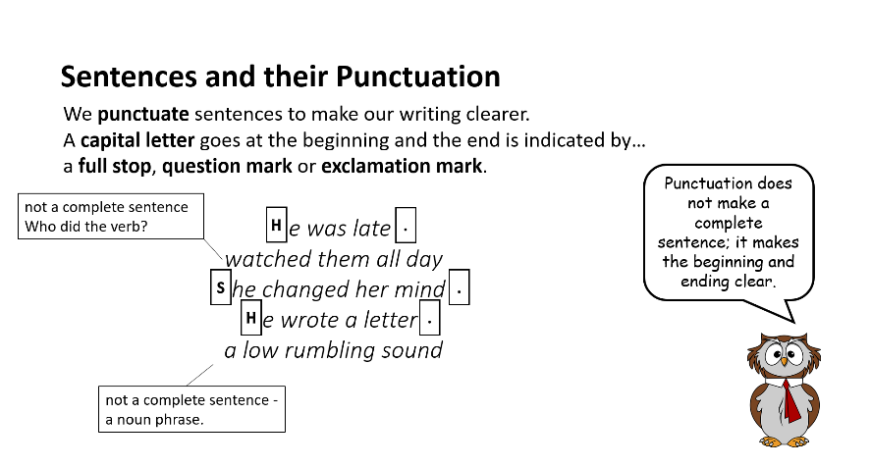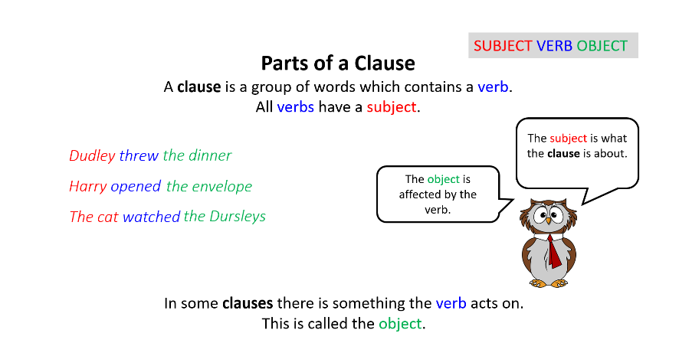

Practice Exercises 1
Day 3

Complete Sentences?

- Read each line of numbered text. They are all supposed to be complete sentences.

- Rewrite each on a piece of lined paper, adding punctuation and extending and completing the sentence as you need to.

- Read each sentence through to check for sense and punctuation.

- tried to grab the letter
- she took it curiously and read the first line
- for a moment, it looked as though she might faint
- clutched her throat and made a choking noise
- Harry and Dudley had a furious but silent fight over
- his glasses dangling from one ear
- seeming to have forgotten that Harry was in the room
- as Dudley wasn’t used to sharing
- not moving
- Harry stared
- that evening when Vernon got back from work
- Harry sat down on the bed when
Practice Exercises 2
Day 3

Sentence Punctuation

- Read the letters
- What is wrong with the punctuation in each one?
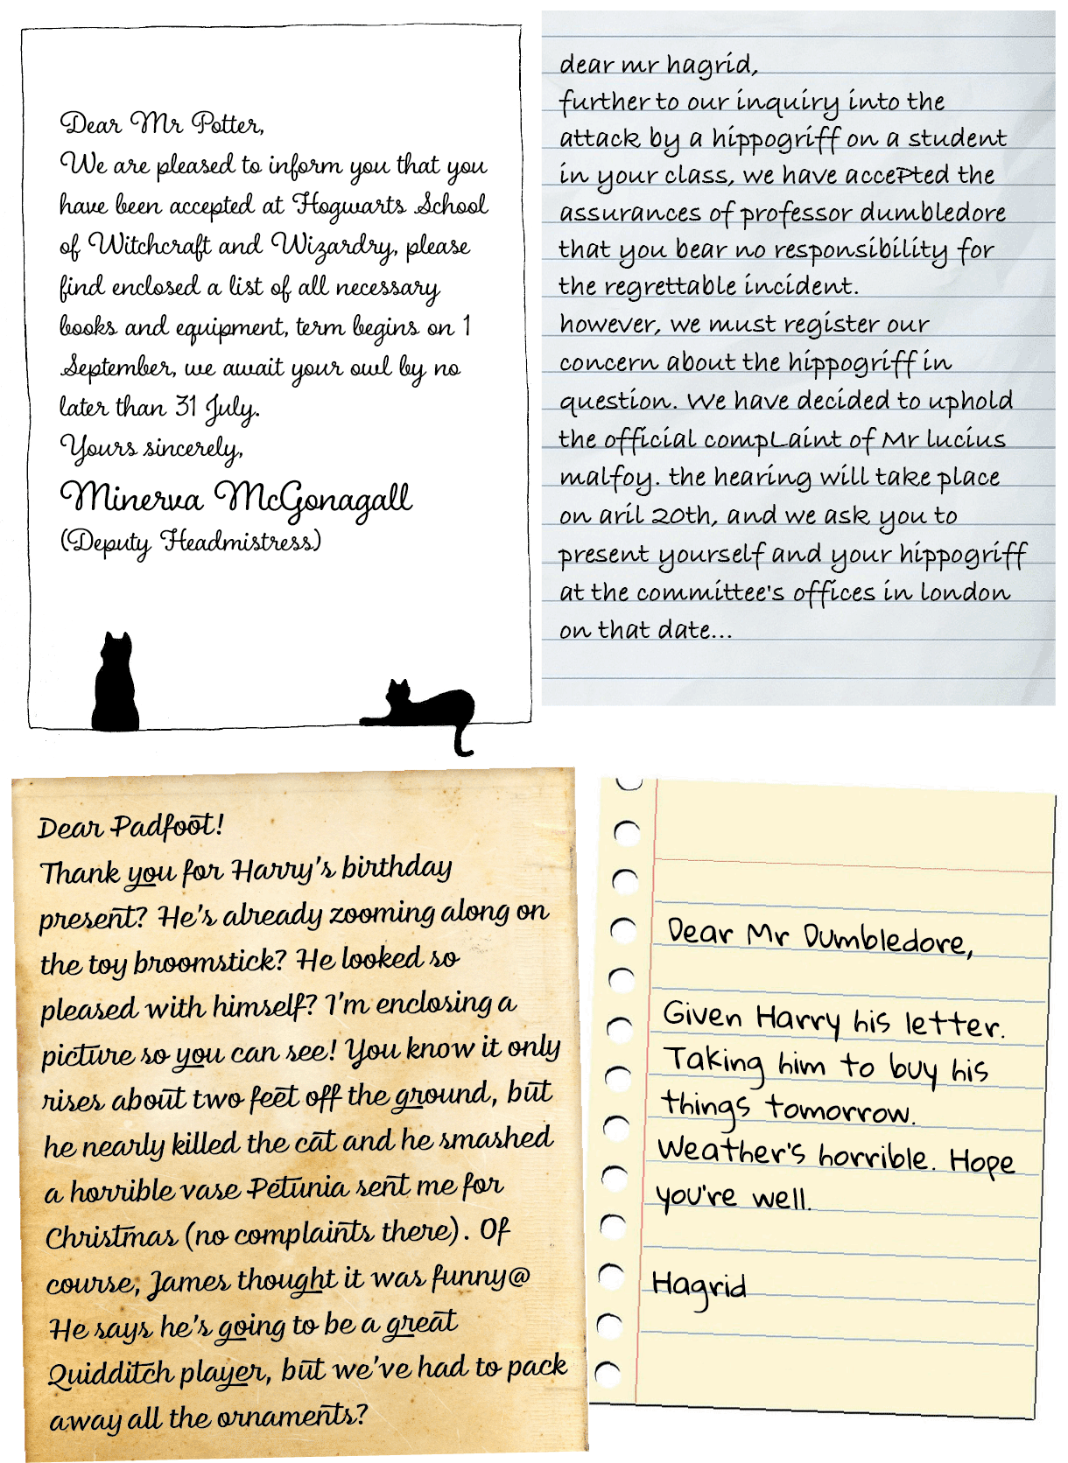
- Write a tip (short piece of advice) to help each writer avoid their mistakes.

Practice Exercises 3
Day 3

Writing clauses and identifying subject, verb and object

- Create your own clauses. Write at least 5 using the columns below.

Subject | Verb | 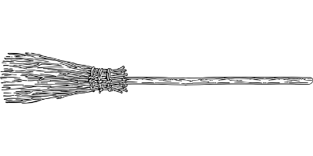  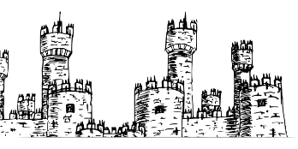  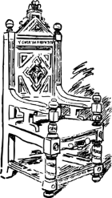  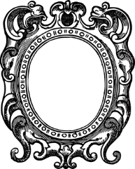  Object  broomstick  castle  tower  chair  mirror
Harry  Dumbledore  The cat  Hagrid  Aunt Petunia | see  ride  find  carry  polish  love  break
e.g. The cat polished the mirror. or Dumbledore carried the chair.
B. Copy each sentence and identify the subject, object and verb.

e.g. They ate stale cornflakes.

- She held a letter.
- Uncle Vernon knocked Harry’s hand.
- He held it out of reach.
- Petunia narrowed her eyes.
- Vernon ignored her.
- Dudley hid his face.
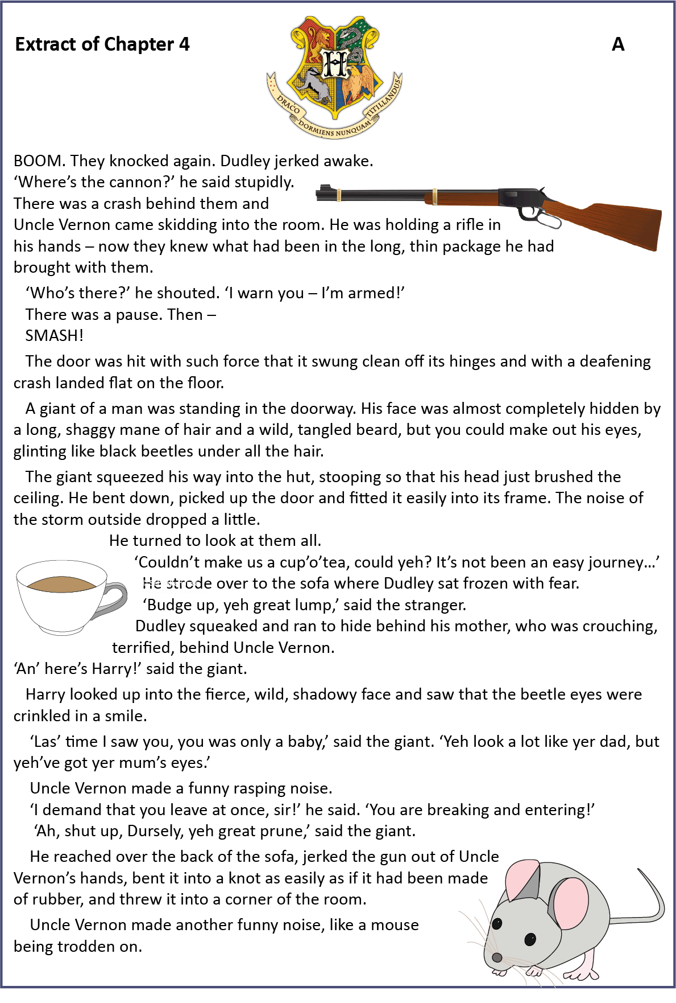
Day 4

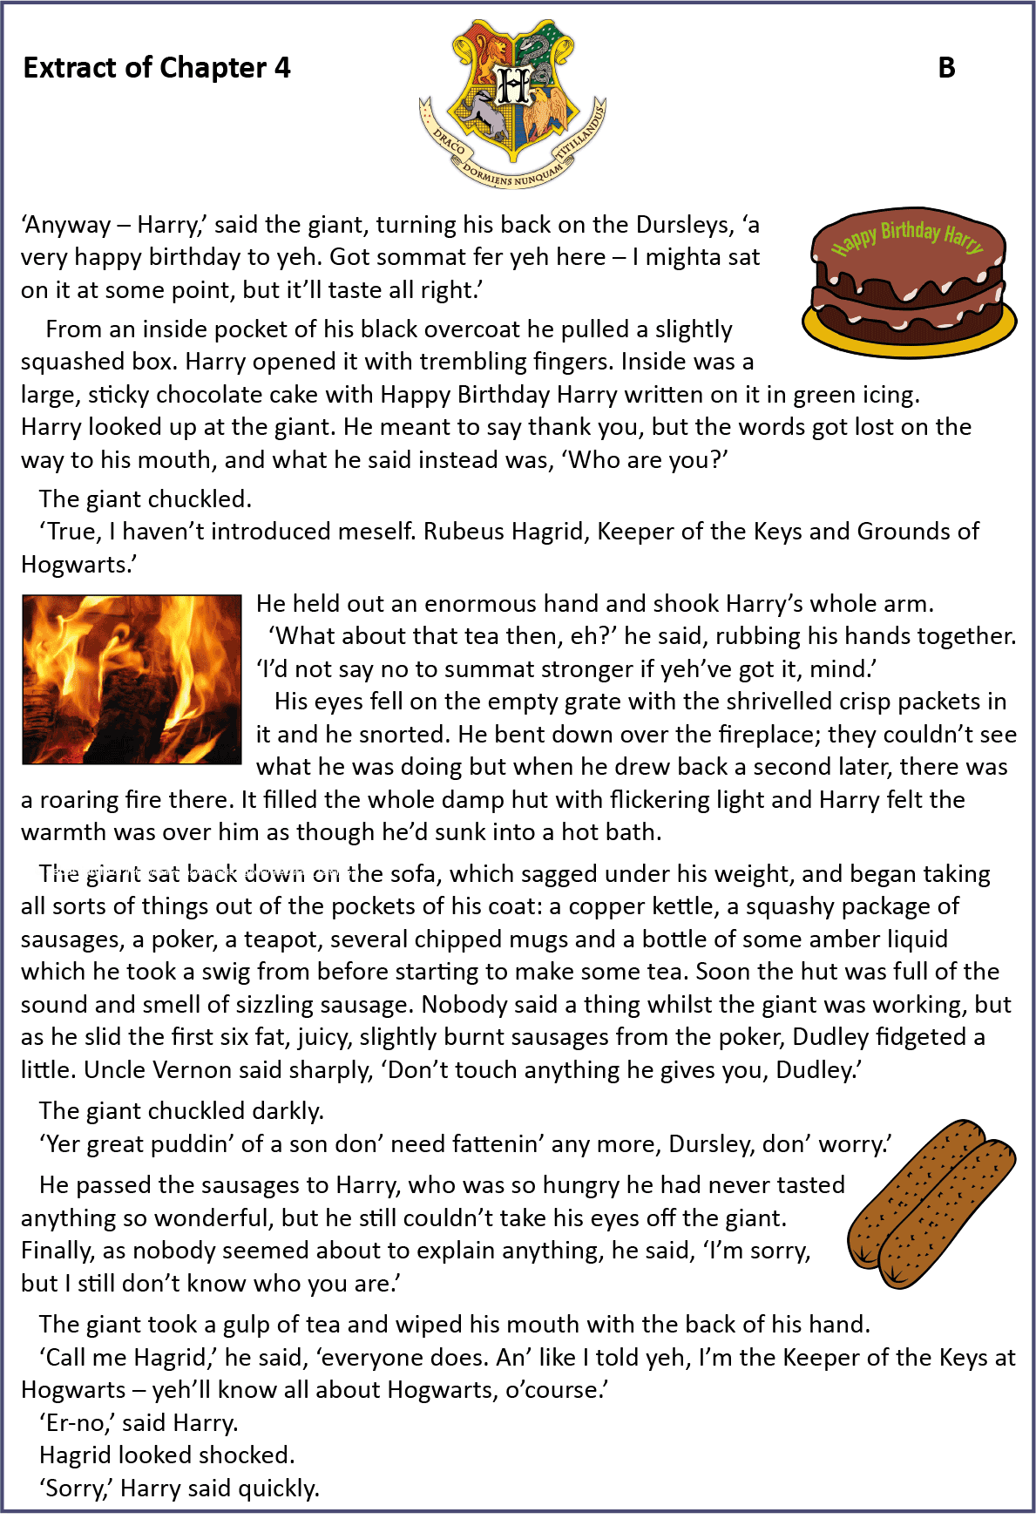
Day 4
Day 4
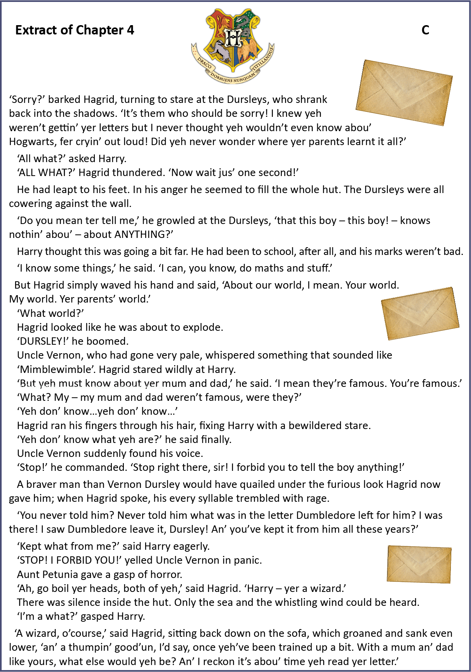
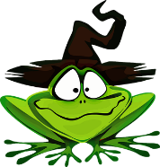
Reading Comprehension A
Day 4

- Read the extracts from Chapter 4.
- Answer the questions on lined paper.
- Work through each section, reading Extract A first and answering the Questions in Box A.

Box A – Questions 1-6 are about Extract A

1) The giant squeezed his way into the hut, stooping so that his head just brushed the ceiling.

Which word is closest in meaning to stooping? Copy.

walking slouching strolling trailing
1 mark

2) Uncle Vernon came skidding into the room.

What does the word skidding suggest about how Vernon is feeling?

____________________________________________________________________________ 1 mark

3) Give one reason why Hagrid might seem frightening when he first appears?

____________________________________________________________________________

____________________________________________________________________________ 1 mark

4) When does Hagrid tell Harry that he last saw him?

____________________________________________________________________________ 1 mark

5) Why do you think Harry is not scared of Hagrid?

____________________________________________________________________________ 1 mark

6) In what ways is Vernon shown to be quite a ridiculous character in this section? Give an example.

____________________________________________________________________________

____________________________________________________________________________ 1 mark

Reading Comprehension B
Day 4
Box B – Questions 7-12 are about Extract B

7) What is the first thing that Hagrid gives to Harry?

____________________________________________________________________________ 1 mark

8) He held out an enormous hand and shook Harry’s whole arm.

What two clues to the fact that Hagrid is a giant are given in the sentence above.

a._________________________________________________________________________

b._________________________________________________________________________ 1 mark

9) He bent down over the fireplace; they couldn’t see what he was doing but when he drew back a second later, there was a roaring fire there.

What does the word drew mean in this context?

____________________________________________________________________________ 1 mark

10) Why does Rowling list the contents of Hagrid’s pockets?

____________________________________________________________________________

____________________________________________________________________________ 1 mark

11) How can the reader tell that Harry is confused or astonished by Hagrid. Write one example below.

____________________________________________________________________________ 1 mark

12) What is unusual about the way that Hagrid speaks? Give an example.

____________________________________________________________________________

____________________________________________________________________________ 1 mark

Reading Comprehension C
Day 4
Box C – Questions 13-15 are about Extract C

13) Find 2 speech verbs which show that Hagrid is angry and write them.

a) __________________________ b) ____________________________ 1 mark

14) ‘Do you mean ter tell me,’ he growled at the Dursleys, ‘that this boy – this boy - knows nothin’ about – about ANYTHING?’

How does Harry misunderstand Hagrid’s words? What is Hagrid referring to?

____________________________________________________________________________

____________________________________________________________________________ 2 marks

15) Find the words, ‘STOP! I FORBID YOU!” yelled Uncle Vernon in panic.
Aunt Petunia gave a gasp of horror.

What does Vernon not want Hagrid to do and why do you think this might be?

____________________________________________________________________________

____________________________________________________________________________ 2 marks

16) Now think about all three extracts. Name two adjectives which could describe Hagrid’s personality using evidence from the text to support your answer.

a. ____________________________________________________________________________

____________________________________________________________________________

b. ____________________________________________________________________________

_____________________________________________________________________________ 3 marks

