Courageous Advocacy.
Key Question KS1: Can anyone be a Courageous Advocate?
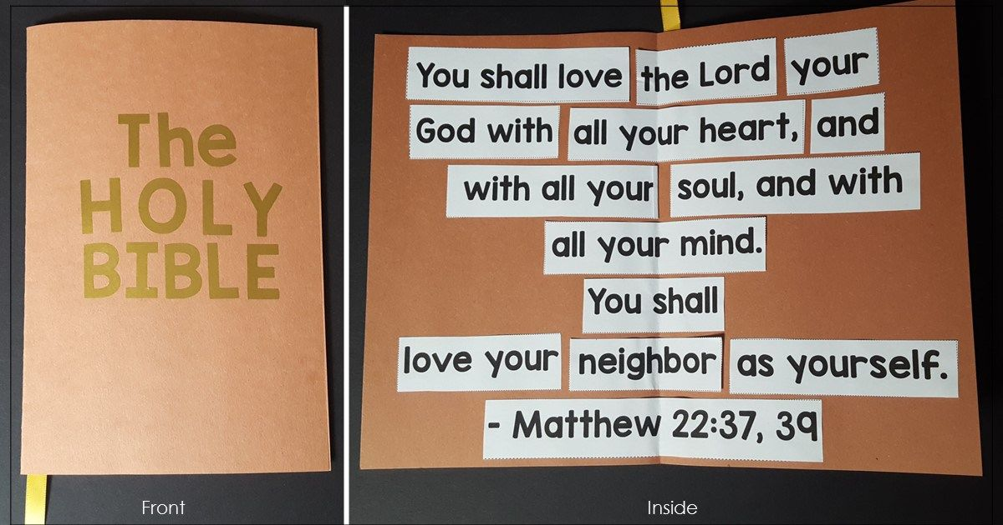
Look at The Great Commandment above.
Research quotes from the Bible regarding God’s messages about courageous advocacy.
Look for quotes in the Bible that talk about looking after the earth and the people and God’s creation.
Useful websites:
https://www.worldvisionadvocacy.org/2017/01/05/17-bible-verses-to-inspire-your-advocacy-in-2017/

https://www.worldvision.org/christian-faith-news-stories/what-does-bible-say-about-advocacy

https://www.biblestudytools.com/topical-verses/bible-verses-about-courage/

Create a display poster using art, quotes and your own ideas to show Biblical representations and messages about Courageous Advocacy.

