Revision Slides 1
Day 1
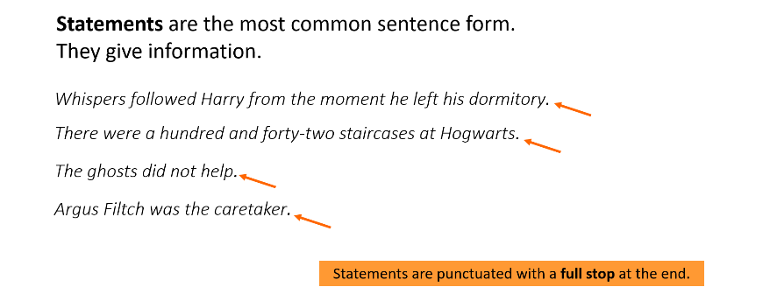
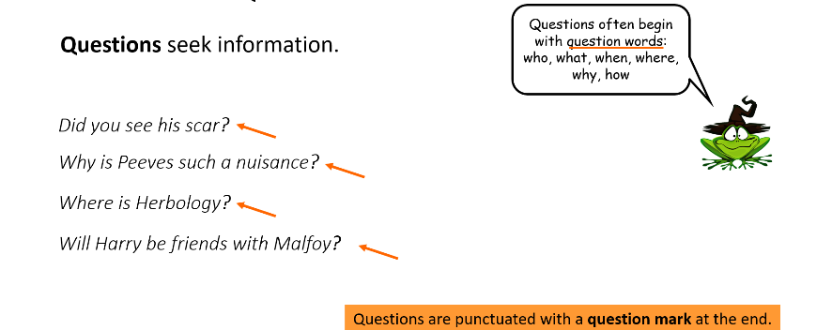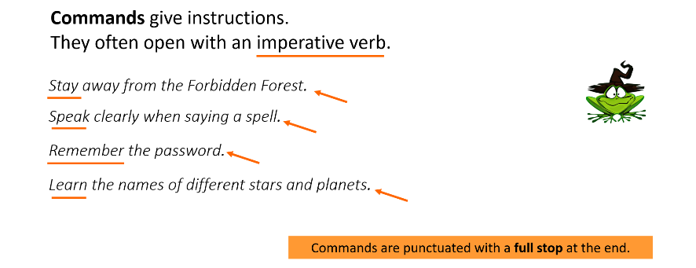
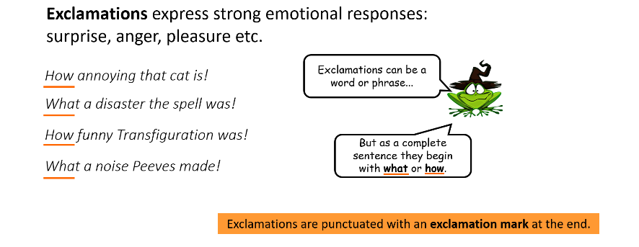
Sentence Forms A - Identify
Day 2
Day 1
Identify the form of each sentence below.
[Write the first letter - Statement, Question, Command, Exclamation]
1
- Take hold of your broom
- What a disaster the spell was
- Owls can carry messages
- What spells can you do
- How old is Hogwarts Castle
- How old Hogwarts Castle is
- Can owls carry messages
- Carry your owl to its perch
Sentence Forms B - Change
Day 1
Rearrange the words to change the sentence form. Write the new sentence.
[Use only the given words. Punctuate correctly.]
2
- This is Potions Class. [QUESTION]
- Are you in Hufflepuff? [STATEMENT]
- How many ghosts are there? [EXCLAMATION]
- You can lose five points. [QUESTION]
- Was that a large puff of smoke? [STATEMENT]
- How strict is Professor Snape? [Exclamation]
Sentence Forms C - Create
Day 1
Write a sentence of each form (4) about the following topics:

3
Hagrid
Malfoy
Wands
Magic
Revision Slides 2
Day 2
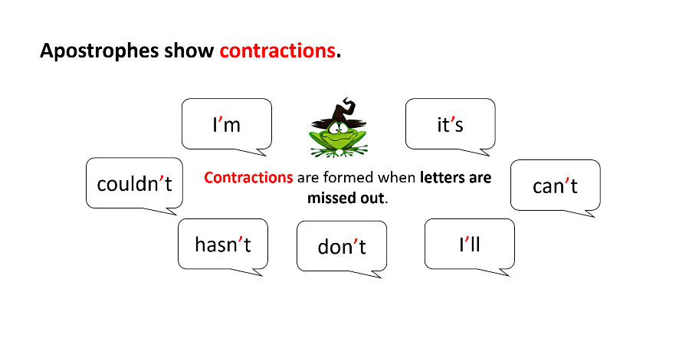
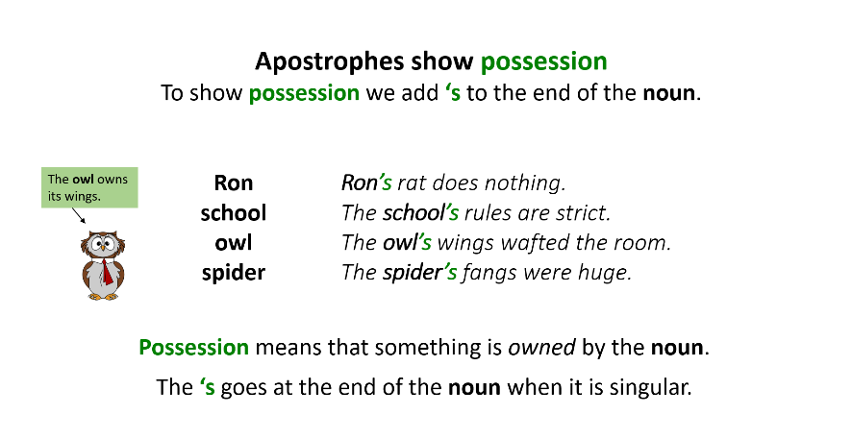
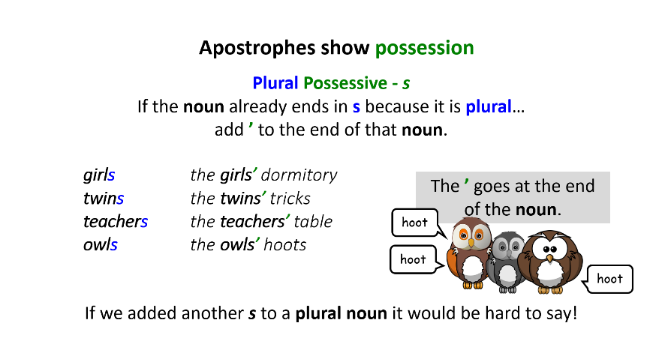
Apostrophes A - Contractions
Day 2
Copy the words with apostrophes which indicate contraction.
1
- Neville’s parcel isn’t what he expected. It’s a Remembrall from his grandmother.
- Harry’s owl didn’t bring him post usually, so he wasn’t expecting anything.
- Ron wouldn’t like to be Hermione’s partner as they’d end up arguing.
- Malfoy’s cruelty couldn’t be ignored by Harry. He wouldn’t say such things.

Write the expanded forms of the contractions.
2
We’ll meet you in the trophy room that’s always locked.
a.
b.
c.
e.
d.
f.

Can’t a person eat in peace in this place?

You mustn’t go wandering round the school at night. Think of the points you’ll lose Gryffindor if you’re caught.

Day 2
Apostrophes B – Possession (singular)
Copy the words where the apostrophes which indicate possession.
3
- At eight o’clock the arrival of the owls interrupted Hermione’s lecture.
- Harry hadn’t had a single letter since Hagrid’s note.
- Malfoy’s owl was always bringing him packages from his parents.
- Neville’s gift glowed red which meant he’d forgotten something.

Copy and punctuate the sentences below to show possession.
Hint: One sentence does not need any apostrophes.
4
- Professor Snapes lessons were difficult and Harrys temper was tested.
- Herbology was taught in the schools greenhouses.
- Professor Binns lessons were very boring.
- Professor Flitwick taught Charms on a pile of his books.
For each row write a C or a P to show whether the apostrophe is used for a contracted form or possession.
5

Sentence | Apostrophe - contracted form | Apostrophe - possession
- Be quiet in Snape’s lessons. | C | P
- Neville’s in trouble with McGonagall. | C | P
- Quidditch is the school’s main sport. | C | P
- Mrs Norris has bulging eyes like Filch’s. | C | P
- You’ll be sorry you crossed me. | C | P

Apostrophes C – Possession (plural)
Day 2
Choose the sentences which show the correct meaning (write the letter).
6

- The boy’s cauldron melted into a twisted blob. | Two boys, who were sharing a cauldron, melted it.
- The boys’ cauldron melted into a twisted blob.

- The girl’s toilets were haunted. | The toilets, which are used by all of the girls, have a ghost living there
- The girls’ toilets were haunted.

- The twin’s plan was cunning. | Fred had a cunning plan which he had not shared with George.
- The twins’ plan was cunning.

- The bat’s cave was dark. | A solitary bat sleeps in a tiny cave for one.
- The bats’ cave was dark.

Copy and punctuate the sentences below to show possession.
7
- The girls dormitory was covered in slime and toads.
- The owls hoots rung through the hall as they swooped in.
- Rons brothers always knew how to get him cross.
- Nobody could find the cause of the broomsticks failure to fly.
- The childrens one chance of surviving was to stick together.

Arguments
Day 3

From the book
Taken from Chapter 8, Harry Potter and the Philosopher’s Stone
…‘Having a last meal, Potter? When are you getting the train back to the Muggles?’
‘You're a lot braver now you're back on the ground and you've got your little friends with you,’ said Harry coolly. There was of course nothing at all little about Crabbe and Goyle, but as the High Table was full of teachers, neither of them could do more than crack their knuckles and scowl.
‘I'd take you on any time on my own,’ said Malfoy. ‘Tonight, if you want. Wizard's duel. Wands only no contact. What's the matter? Never heard of a wizard’s duel before, I suppose?’
‘Of course he has,’ said Ron, wheeling round. ‘I’m his second, who's yours?’
Malfoy looked at Crabbe and Goyle, sizing them up.
‘Crabbe, he said. “Midnight all right? We'll meet you in the trophy room, that’s always unlocked.’…
Script Version

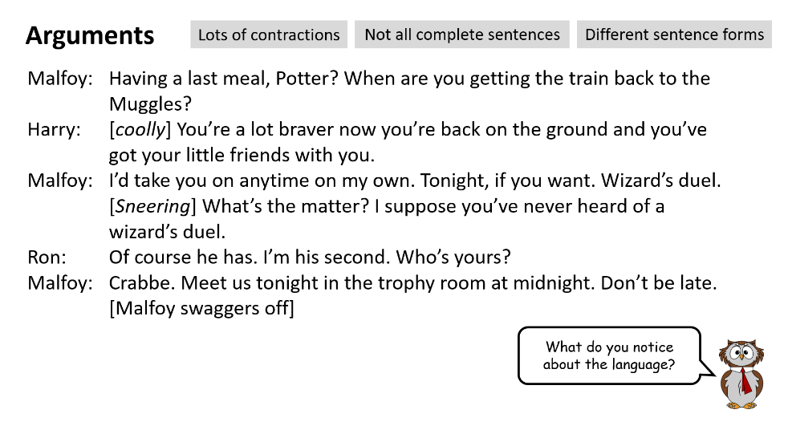
Reading Comprehension Text, A
Day 4

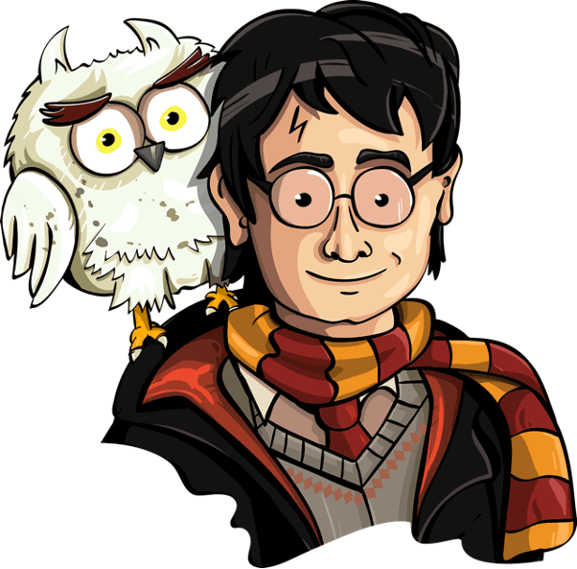
‘What’s he doing?’ Harry whispered. ‘Why isn’t he down in the dungeons with the rest of the teachers?’
‘Search me.’
Quietly as possible, they crept along the next corridor after Snape’s fading footsteps.
‘He’s heading for the third floor,’ Harry said, but Ron held up his hand.
‘Can you smell something?’
Harry sniffed and a foul stench reached his nostrils, a mixture of old socks and the kind of public toilet no one seems to clean.
And then they heard it – a low grunting and the shuffling of gigantic feet. Ron pointed: at the end of the passage to the left, something huge was moving towards them. They shrank into the shadows and watched as it emerged into a patch of moonlight.
It was a horrible sight. Twelve feet tall, its skin was a dull, granite grey, its great lumpy body like a boulder with its small bald head perched on top like a coconut. It had short legs thick as tree trunks with flat, horny feet. The smell coming from it was incredible. It was holding a huge wooden club, which dragged along the floor because its arms were so long.
The troll stopped next to a doorway and peered inside. It waggled its long ears, making up its tiny mind, then slouched slowly into the room.
‘The key’s in the lock,’ Harry muttered. ‘We could lock it in.’

Reading Comprehension, A
Day 4

- Read the extracts from Chapter 10.
- Answer the questions.
- Work through each section at a time, reading Extract A first and answering the Questions from Box A.

Box A – Questions 1-5 are about Extract A

1) Where are most of the teachers?

____________________________________________________________________________ 1 mark

2) Name two things Harry and Ron notice which warn them that the troll is nearby, before they see it.

____________________________________________________________________________

____________________________________________________________________________ 1 mark

3) They shrank into the shadows and watched as it emerged into a patch of moonlight.

Which word is closest in meaning to shrank? Copy one.

deflated shortened shook retreated
1 mark

4) How is the troll ‘like a boulder’?

____________________________________________________________________________

____________________________________________________________________________ 1 mark

5) The troll stopped next to a doorway and peered inside. It waggled its long ears, making up its mind, then slouched slowly into the room.

Choose one interesting verb from the text above. What image of the troll does the verb create?

____________________________________________________________________________

____________________________________________________________________________ 1 mark

Reading Comprehension Text, B
Day 4

They edged towards the open door, mouths dry, praying the troll wasn’t about to come out of it. With one great leap, Harry managed to grab the key, slam the door and lock it.
Flushed with their victory they started to run back up the passage, but as they reached the corner they heard something that made their hearts stop – a high, petrified scream – and it was coming from the chamber they’d just locked up.
‘Oh, no,’ said Ron, pale as the Bloody Baron.
‘It’s the girls’ toilets!’ Harry gasped.
‘Hermione!’ they said together.
It was the last thing they wanted to do, but what choice did they have? Wheeling around they sprinted back to the door and turned the key, fumbling in their panic – Harry pulled the door open – they ran inside.
Hermione Granger was shrinking against the wall opposite, looking as if she was about to faint. The troll was advancing on her, knocking the sinks off the walls as it went.
‘Confuse it!’ Harry said desperately to Ron, and seizing a tap he threw it as hard as he could against the wall. The troll stopped a few feet from Hermione. It lumbered around, blinking stupidly, to see what had made the noise. Its mean little eyes saw Harry. It hesitated, then made for him instead, lifting its club as it went.
‘Oy, pea-brain!’ yelled Ron from the other side of the chamber, and he threw a metal pipe at it. The troll didn’t even seem to notice the pipe hitting its shoulder, but it heard the yell and paused again, turning its ugly snout towards Ron instead, giving Harry time to run around it.
‘Come on, run, run!’ Harry yelled at Hermione, trying to pull her towards the door, but she couldn’t move, she was still flat against the wall, her mouth open with terror.
The shouting and the echoes seemed to be driving the troll berserk. It roared again and started towards Ron, who was nearest and had no way to escape.
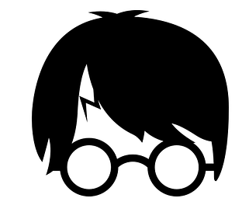
Harry then did something that was very brave and very stupid: he took a great running jump and managed to fasten his arms around the troll’s neck from behind. The troll couldn’t feel Harry hanging there, but even a troll would notice if you stick a long bit of wood up its nose, and Harry’s wand had still been in his hand when he’d jumped – it had gone straight up one of the troll’s nostrils.
Howling with pain, the troll twisted and flailed its club, with Harry clinging on for dear life; any second, the troll was going to rip him off or catch him a terrible blow with the club.
Hermione had sunk to the floor in fright; Ron pulled out his own wand – not knowing what he was going to do he heard himself cry the first spell that came into
his head:
Reading Comprehension B
Day 4
Box B – Questions 6-10 are about Extract B

6) …as they reached the corner they heard something that made their hearts stop…

Who is making the noise and why does it make ‘their hearts stop’?

____________________________________________________________________________ 1 mark

7) Name two things that Harry and Ron do to distract the troll.

a._________________________________________________________________________

b._________________________________________________________________________ 1 mark

8) The shouting and the echoes seemed to be driving the troll berserk.

What does the word berserk mean in this context?

____________________________________________________________________________ 1 mark

9) Find and copy a group of words which show that the troll has dull senses.

____________________________________________________________________________

____________________________________________________________________________ 1 mark

10) …or catch him a terrible blow with the club.

What does the word blow mean in this context? Name another synonym which could replace it?

____________________________________________________________________________

____________________________________________________________________________ 2 marks

Reading Comprehension Text, C
Day 4

‘Wingardium Leviosa!’
The club flew suddenly out of the troll’s hand, rose high, high up into the air, turned slowly over – and dropped, with a sickening crack, on to its owner’s head. The troll swayed on the spot and then fell flat on its face, with a thud that made the whole room tremble.
Harry got to his feet. He was shaking and out of breath. Ron was standing there with his wand still raised, staring at what he had done.
It was Hermione who spoke first.
‘Is it – dead?’
‘I don’t think so,’ said Harry. ‘I think it’s just been knocked out.’
He bent down and pulled his wand out of the troll’s nose. It was covered in what looked like lumpy grey glue.
‘Urgh – troll bogies.’
He wiped it on the troll’s trousers.
A sudden slamming and loud footsteps made the three of them look up. They hadn’t realised what a racket they had been making, but of course, someone downstairs must have heard the crashes and the troll’s roars. A moment later, Professor McGonagall had come bursting into the room, closely followed by Snape, with Quirrell bring up the rear. Quirrell took one look at the troll, let out a faint whimper and sat quickly on the toilet, clutching his heart.
Snape bent over the troll. Professor McGonagall was looking at Ron and Harry. Harry had never her seen her look so angry. Her lips were white. Hopes of winning fifty points for Gryffindor faded quickly from Harry’s mind.
‘What on earth were you thinking of?’ said Professor McGonagall, with cold fury in her voice. Harry looked at Ron, who was standing with his wand in the air. ‘You’re lucky you weren’t killed. Why aren’t you in your dormitory?’
Snape gave Harry a swift, piercing look. Harry looked at the floor. He wished Ron would put his wand down.
Then a small voice came out of the shadows.
‘Please, Professor McGonagall – they were looking for me.’
‘Miss Granger!’
Hermione had managed to get to her feet at last.
‘I went looking for the troll because I – I thought I could deal with it on my own – you know, because I’ve read all about them.’
Ron dropped his wand. Hermione Granger, telling a downright lie to a teacher?
‘If they hadn’t found me, I’d be dead now. Harry stuck his wand up its nose and Ron knocked it out with its own club. They didn’t have time to come and fetch anyone. It was about to finish me off when they arrived.’

Reading Comprehension C
Day 4
Box C – Questions 11-14 are about Extract C

11) What happens to make the troll unconscious?

____________________________________________________________________________ 1 mark

12) What makes Ron finally move after being frozen in shock?

____________________________________________________________________________

____________________________________________________________________________ 2 marks

13) Write T or F to show whether each statement is true or false.

 | True | False
- Harry spoke first after the troll fell.
- Quirrell fainted when he saw the troll.
- The teachers first noticed Hermione when she stood up.
- Ron knew that Hermione would tell a lie to the teachers.

2 marks

14) Now think about all three extracts. Why are Hermione’s actions surprising? Why do you think that she lies about what had happened? Can you explain your thinking?

____________________________________________________________________________

____________________________________________________________________________

____________________________________________________________________________

____________________________________________________________________________ 3 marks

Task Guide
Day 5

You will be writing instructions to go into an unoffical textbook for students at Hogwarts. You should use instructional structure and language features. You can think of your own topic or use one from the list:

How to defeat a troll
How to win a wizard duel
How to survive potions class
How to deal with ghosts
How to use secret passageways

- Once you have chosen your topic, make brief notes on a piece of paper using the green box to help you.
- Then take a new lined piece of paper and write your instructions using the language features in the purple box.

Language Features

- Impersonal/technical language
- Imperative verbs
- Present tense
- Adverbs for time and manner
- Commands and statements
Possible structure of Instructions

- Title
- Clear statement of purpose
- Equipment list
- Clear order of steps
- Helpful tips
