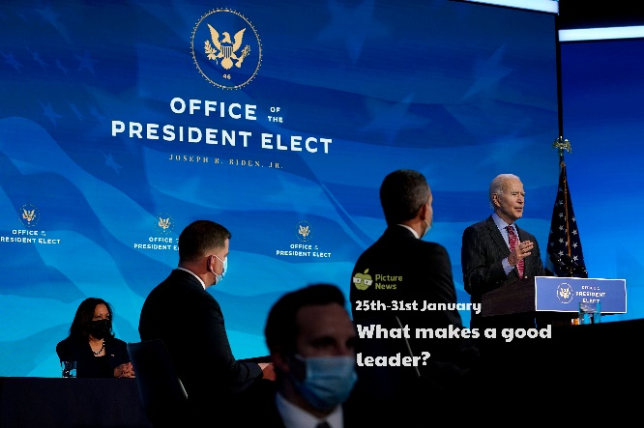 

Design and make a badge for a leader to wear. It might be a new school council, sports crew or playground leader badge or perhaps you could make one for your sports coach, teacher or parents!

Locate the UK on a world map, then locate the United States of America. What continent are each part of? Can you name and locate any other countries or continents?

Create your own sketch or piece of art to represent what leadership means to you. Will you use symbols, words, drawings or a combination in your picture? What colours will you use? Will the tone be bright and deep or pale? Will you use pencils, crayons, pastels, paints or materials?

Lead a fitness session for your family at home or people at school. Once you have finished, ask the people who took part what they thought of your leadership skills!

Imagine you are going to be the Prime Minister for the day! Create a timetable with all the things you plan to do. What time will you get up? Will you schedule in mealtimes and breaks? Will you plan to change any rules or laws? Will you use the Voyager aircraft? Do you plan to address the nation? Don’t forget to include times. You could decide whether to record these in 12 or 24-hour clock.

Make a list of some of your leaders, e.g. your sports coach, your teacher, your parents. Choose one of your leaders to create an interview to find out more about them. You could include: What do you lead? Do you enjoy being a leader? Do you think you are a good leader? What do you find hard about being a leader? If possible, ask your questions and listen to the answers carefully. Draw a picture and write about your leader.

**Learning from home**

Use the ideas below, alongside this week’s resource, to support your home learning.