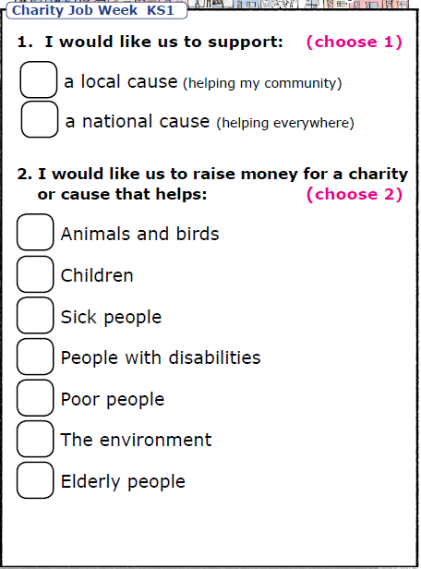
Create a poster to explain what you would like to do to help.

