Self assessment
LO: Identify adjectives
Adjectives
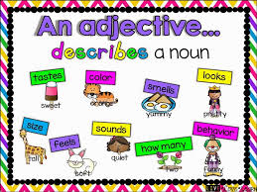
Complete the word map to describe your
favourite character.
Draw a picture of your favourite character

Adjectives

Self assessment
LO: Use adjectives
Adjectives

Use your adjectives from your word map to write sentences about your character.
My character: _____________________

