Self assessment
LO: Identify adverbs
Adverbs
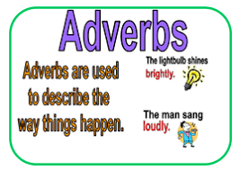

An adverb tells you how it happened.

Example: Quickly

Adverbs

Self assessment
LO: Use adverbs
Adverbs
An adverb tells you how it happened.

Example: He ran quickly.

Use the adverbs from your word map in sentences.

