men | woman | roads | aqueducts | canals | railways
bridges | ships | dockyards | engineers | improved science education for girls | inspired women to study engineering
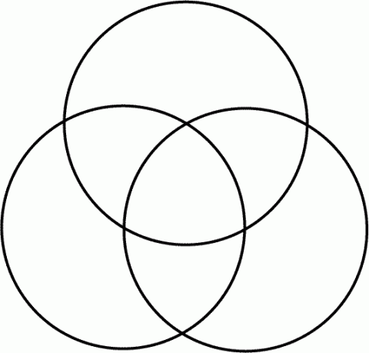
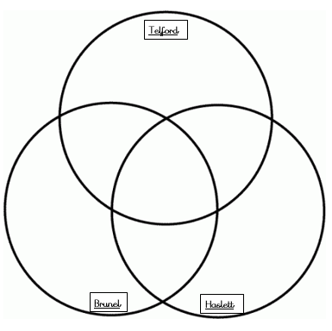
Answers
Haslett
Brunel
Telford
canals
aqueducts
roads
ships
dockyards
engineers
Improved science education for girls
Inspired women to study engineering
bridges
railways
woman
men

