

**Leaves**

One of the best ways to tell what type of tree it is, is from the shape and size of its leaves. Some are larger than others! Look at the leaves below.

* Can you point to the biggest?
* Which is the smallest?
* Can you order them largest to smallest?

Measure the length of each leaf and record it. You might use non-standard units such as multilink, pasta shapes, pencils, paperclips, or standard units such as a ruler.

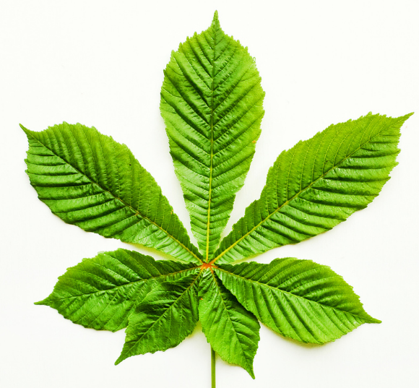

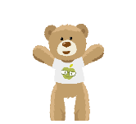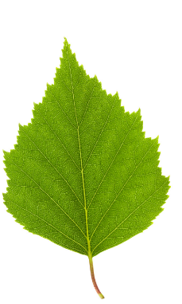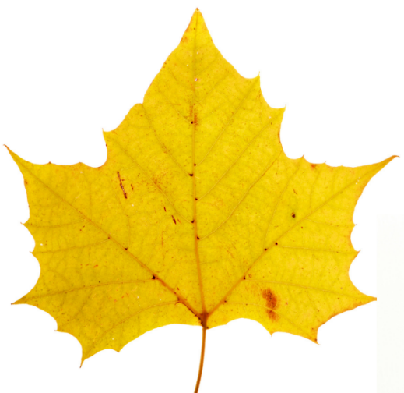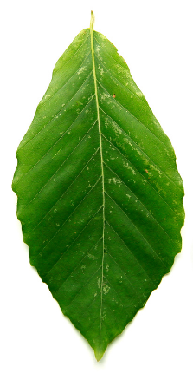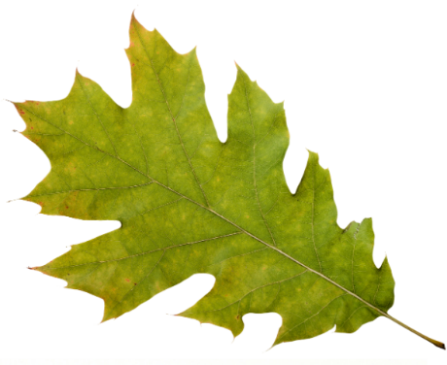

**Challenge – can you name the tree any of these leaves come from?**