Spring Term Year 1 Mrs Breeze
Let’s Build Spring 1
Time Travellers Spring 2

Topic texts | Knowledge | Skills | Enrichment  Opportunities
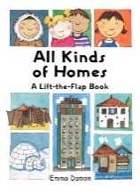  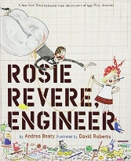  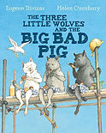  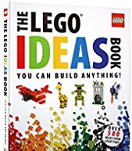  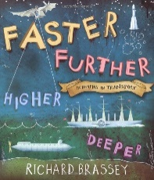  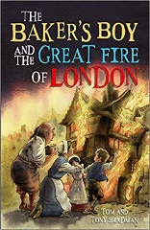  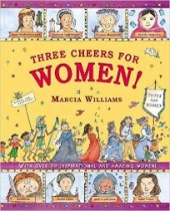  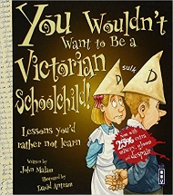 | English  - Develop phonic awareness to be able to read and write words  - Use simple punctuation to demarcate sentences  - Consider what they are going to write before beginning  - Make simple additions, revisions and corrections to their own writing  - Genres: Story – telling, traditional tales, recount of events, setting and character description. Non-fiction information text, letter writing  - Instruction, labels and Informational Text (writing to inform)  - Stories with historical contexts  - Poetry – adjectives, vocabulary building, structure – vocabulary building. | Reading  Develop positive attitudes to reading, and an understanding of what they read  Understand what they read, in books they can read independently  Retrieve and record information from non-fiction  Participate in discussion about both books that are read to them and those they can read for themselves, taking turns and listening to what others say.  Writing  Plan, draft and write by:  composing and rehearsing sentences orally (including dialogue), progressively building a varied and rich vocabulary and an increasing range of sentence structures  Evaluate and edit  Proofread for spelling and punctuation errors  Read their own writing aloud, to a group or the whole class, using appropriate intonation and controlling the tone and volume so that the meaning is clear.  Increase the legibility, consistency and quality of their handwriting | STEM  Lego Builders  Great Fire of London Enrichment – Local Fire Engine visit?  World Book Day  Shakespeare Week
 | Maths  (White Rose Scheme)  - Place value  - Addition and Subtraction  - Measurement – length and height  - Measurement – weight and volume | Number & Place Value  - count to and across 100, forwards and backwards, beginning with 0 or 1, or from any given number  - count, read and write numbers to 100 in numerals; count in multiples of 2s, 5s and 10s  - given a number, identify 1 more and 1 less  - identify and represent numbers using objects and pictorial representations including the number line, and use the language of: equal to, more than, less than (fewer), most, least  - read and write numbers from 1 to 20 in numerals and words.  Addition & Subtraction  - read, write and interpret mathematical statements involving addition (+), subtraction (-) and equals (=) signs  - represent and use number bonds and related subtraction facts within 20  - add and subtract one-digit and two-digit numbers to 20, including 0  - solve one-step problems that involve addition and subtraction, using concrete objects and pictorial representations, and missing number problems such as 7 = ? - 9.  Measurement  compare, describe and solve practical problems for:  - lengths and heights (for example, long/short, longer/shorter, tall/short, double/half)  - mass / weight  - capacity and volume  - time  measure and begin to record the following:  - lengths and heights  - mass/weight  - capacity and volume  - time (hours, minutes, seconds)
 | Science  Everyday Materials – identify, compare and explore different materials, their properties and uses.  Weather (Spring & Summer) – explore the changes across the seasons and describe how day length changes. | - Asking simple questions and recognising that they can be answered in different ways  - Observing closely, using simple equipment  - Performing simple tests  - Using their observations and ideas to suggest answers to questions  - Gathering and recording data to help in answering questions.  - identify and compare the suitability of a variety of everyday materials, including wood, metal, plastic, glass, brick, rock, paper and cardboard for different uses  - compare how things move on different surfaces.  - find out how the shapes of solid objects made from some materials can be changed by squashing, bending, twisting and stretching  - observe changes across the 4 seasons  - observe and describe weather associated with the seasons and how day length varies.
 | History  (cross curricular)  To understand how to use a timeline to support chronological understanding and to explore the past, asking questions by looking at buildings from different eras.  Changes within living memory to reveal aspects of change in national life, To collect information about history in local area, events beyond living memory that are significant nationally or globally, the lives of significant individuals in the past who have contributed to national and international achievements. (Samuel Pepys, Thomas Telford) | - Use timelines to place events in order.  - Use historical vocabulary e.g. year, decade.  - Use evidence to find out how things have changed during a time period.  - Describe how some of the past events/people affect life today  - Use printed sources, the internet, pictures, photos, music, artefacts, historic buildings and visits to collect information about the past.  - Ask questions such as ‘how did people ….? What did people do for……?  - Suggest sources of evidence to use to help answer questions  - Present findings about past using speaking, writing, computing and drawing skills.  - Discuss different ways of presenting information for different purposes.
 | Geography  Location / Place Knowledge and Geographical Skills and Fieldwork  Compare Dawley to London and locate on a map.  Explore different climates, ways of life and houses of different populations around the world. | Explore using maps to find the countries that make up the UK and the surrounding seas.  Use world maps, atlases and globes to identify the United Kingdom and its countries, as well as the countries, continents and oceans studied at this key stage such as the North and South Poles.  use simple compass directions (North, South, East and West) and locational and directional language to describe the location of features and routes on a map  use aerial photographs and plan perspectives to recognise landmarks and basic human and physical features; devise a simple map; and use and construct basic symbols in a key  use simple fieldwork and observational skills to study the geography of their school and its grounds and the key human and physical features of its surrounding environment.  identify seasonal and daily weather patterns in the United Kingdom and the location of hot and cold areas of the world in relation to the Equator and the North and South Pole
 | Computing  Lego Builders - To emphasise the importance of following instructions; to follow and create simple instructions on the computer and to consider how the order of instructions affects the result.  Maze Explorers – To understand the functionality of the basic direction keys and how to create and debug a set of instructions (algorithm); to use the additional direction keys as part of their algorithm and to understand how to change and extend the algorithm list; to create a longer algorithm for an activity; to provide an opportunity for the pupils to set challenges for each other.  Animated Story Books – Introduce e-books and 2Create a Story; to add animation to a story and to work on a more complex story, including adding backgrounds and copying and pasting pages. | To use vocabulary such as algorithm, debug and program.  - understand what algorithms are; how they are implemented as programs on digital devices; and that programs execute by following precise and unambiguous instructions create and debug simple programs  - use logical reasoning to predict the behaviour of simple programs  - use technology purposefully to create, organise, store, manipulate and retrieve digital content  - recognise common uses of information technology beyond school  - use technology safely and respectfully, keeping personal information private; identify where to go for help and support when they have concerns about material on the internet or other online technologies
 | Music  Charanga Scheme yr1 | - use their voices expressively and creatively by singing songs and speaking chants and rhymes  - play tuned and untuned instruments musically  - listen with concentration and understanding to a range of high-quality live and recorded music  - experiment with, create, select and combine sounds using the interrelated dimensions of music | Charanga  *Famous musicians* composer of the month/term covered in assembly.
 | PE  Indoor and Outdoor | - Pupils explore simple skills. They copy, remember, repeat and explore simple action with control and co- ordination.  - They begin to show some understanding of simple tactics and basic compositional ideas.  - They talk about differences between their own and others’ performance and suggest improvements.  - They understand how to exercise safely, and describe how their bodies feel during different activities.
 | RE  Creation  Who made the World?  Sikhism - Exploring other religions.  What do Sikh’s believe? | - Retell the story of creation from Genesis 1:1 – 2,3 simply  - Recognise that ‘Creation’ is the beginning of the ‘big story’ of the Bible  - Say what the story tells Christians do to say thank you to God for his creation  - Think, talk and ask questions about living in this amazing world.  - To understand other religions and what they believe.
 | PSHE  Relationships  - Feelings and emotions  - Healthy relationships  - Valuing differences | - Recognising feelings in self and others; sharing feelings  - Secrets and keeping safe; special people in their lives  - Respecting similarities and differences in others; sharing views and ideas

