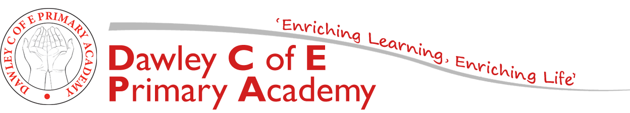
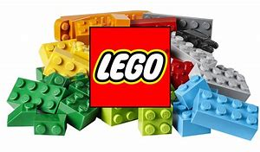

Year 1: Homework

Enjoy books and love reading
Year 1 pupils are expected to read at least 3 times a week and have it recorded in individual reading diaries. (This could be a school book, a book at home, magazine or comic). Children who read three times a week or more at home, will win a prize on Friday. Reading must be recorded in their reading diaries for them to win a prize.
Quicken mental maths skills
Children should practise number bonds to 10 (the two digits that add up to 10) and know that 9+1 = 10 so 1+9 =10. Familiarise your child with 2 and 5 timetables.
Themed Homework Activities
The tasks cover a range of different areas of learning and vary in the level of adult input required. They are all based on our topic and will enhance the work we complete in class. The homework book is to be handed in at the end of this half term on Wednesday 10th February 2021 so that we can celebrate all homework completed so far. If you need any ideas/materials to complete any tasks, please ask. Thank you for your continued support.
Mrs Breeze
Task 1:  Literacy:  Keep practising phonics.  Imagine you are a master builder. Can you draw your dream house and use adjectives to describe it? | Task 2:  Maths:  Practise number bonds to 10 and 20, addition and subtraction. | Task 3:  Science:  Use Lego or building blocks to create a house or room.  What about other types of homes: igloo, stilt home, tent?
Task 4:  Geography:  Talk a walk around your local area and look at buildings. Are they the same or different? Can you draw a map of your walk and label the buildings? | Spring 1 Topic  Let’s Build! | Task 5:  Art:  Try a detailed observational drawing of your own house or create your imaginative dream house
Task 6:  RE:  Churches are often referred to as God’s House. Can you draw a picture of God’s House?  Find out about buildings of worship from other religions. | Task 7:  Reading:  Read stories related to ‘houses’ e.g.  ‘The Three Little Pigs’, ‘The House That Jack Built’.  Can you write a book review: what did you like/dislike about the story? | Task 8:  Geography:  Find out about homes in three different countries. What are the similarities and differences between them?

