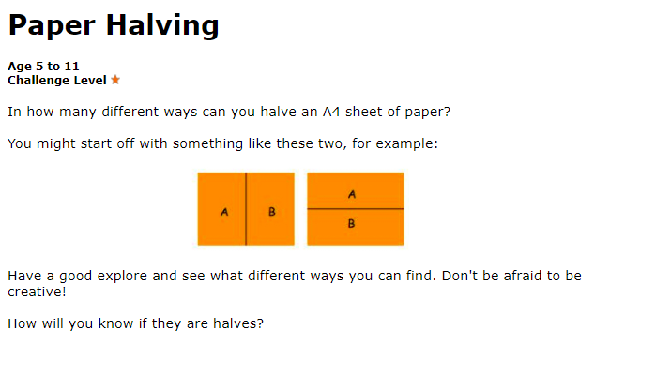

Tell me about your halves.
How do you know this is a half?
Can you find some other ways of halving the paper?

