Can you use the Oceans and Continents Name cards to label the map below? Once you’ve had a go, check your answers.
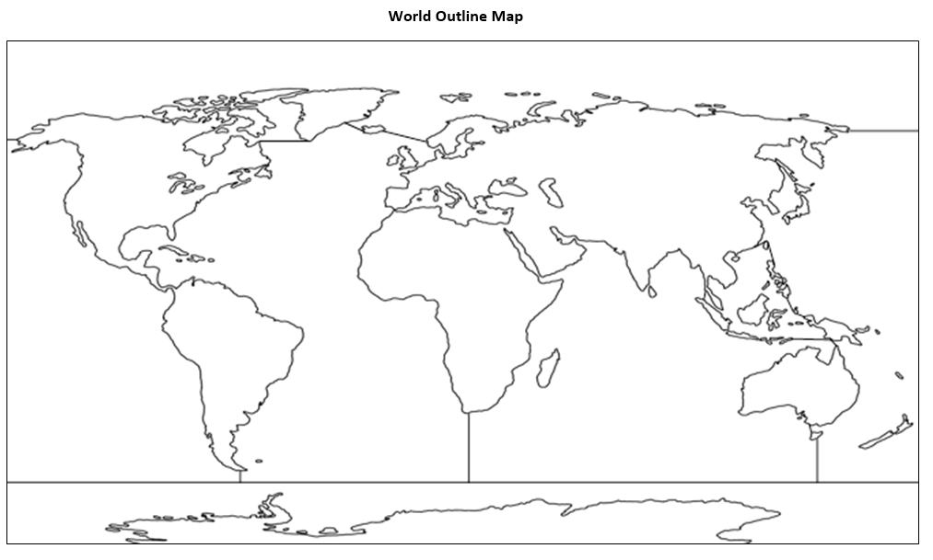
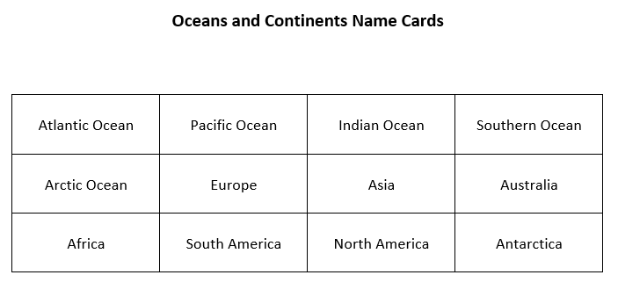

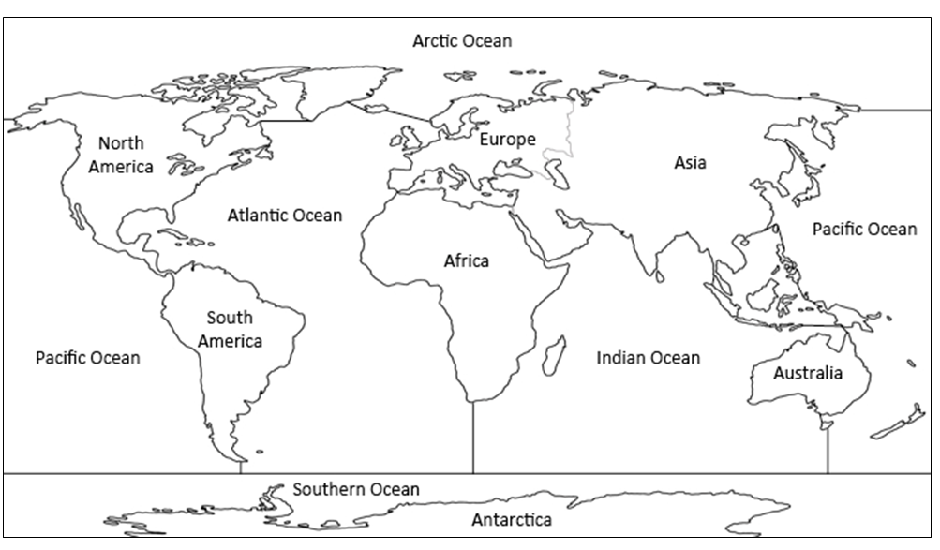
ANSWERS

