Spring Term Year 1 Mrs Breeze
Explorers Summer 1
Come Dine With Me Summer 2

Topic texts | Knowledge | Skills | Enrichment  Opportunities
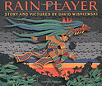  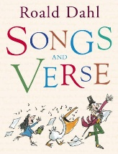  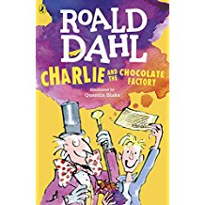  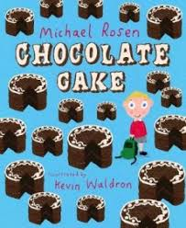  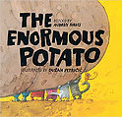  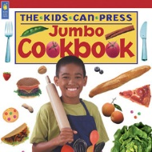  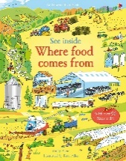  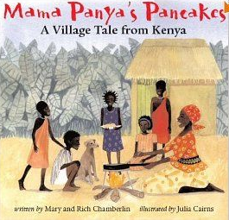 | English  (Read Write Inc Phonics and Get Writing Scheme)  - Develop phonic awareness to be able to read and write words  - Use simple punctuation to demarcate sentences  - Consider what they are going to write before beginning  - Make simple additions, revisions and corrections to their own writing  - Genres: Story – telling, traditional tales, recount of events, setting and character description. Non-fiction information text, letter writing  - Instruction, labels and Informational Text (writing to inform)  - Stories with historical contexts  - Poetry – adjectives, vocabulary building, structure – vocabulary building. | Reading  Develop positive attitudes to reading, and an understanding of what they read  Understand what they read, in books they can read independently  Retrieve and record information from non-fiction  Participate in discussion about both books that are read to them and those they can read for themselves, taking turns and listening to what others say.  Writing  Plan, draft and write by:  composing and rehearsing sentences orally (including dialogue), progressively building a varied and rich vocabulary and an increasing range of sentence structures  Evaluate and edit  Proofread for spelling and punctuation errors  Read their own writing aloud, to a group or the whole class, using appropriate intonation and controlling the tone and volume so that the meaning is clear.  Increase the legibility, consistency and quality of their handwriting | STEM  Food tasting
 | Maths  (White Rose Scheme)  - Number: Multiplication and Division  - Number: Fractions  - Geometry: Position and Direction  - Number: Place Value (within 100)  - Measurement – money  - Measurement – time | Number & Place Value  - count to and across 100, forwards and backwards, beginning with 0 or 1, or from any given number  - count, read and write numbers to 100 in numerals; count in multiples of 2s, 5s and 10s  - given a number, identify 1 more and 1 less  - identify and represent numbers using objects and pictorial representations including the number line, and use the language of: equal to, more than, less than (fewer), most, least  - read and write numbers from 1 to 20 in numerals and words.  Multiplication & Division  - solve one-step problems involving multiplication and division, by calculating the answer using concrete objects, pictorial representations and arrays with the support of the teacher.  Measurement  compare, describe and solve practical problems for:  - time  - measure and begin to record:  - time (hours, minutes, seconds)  - recognise and know the value of different denominations of coins and notes  - sequence events in chronological order using language  - recognise and use language relating to dates, including days of the week, weeks, months and years  - tell the time to the hour and half past the hour and draw the hands on a clock face to show these times.  Fractions  - recognise, find and name a half as 1 of 2 equal parts of an object, shape or quantity  - recognise, find and name a quarter as 1 of 4 equal parts of an object, shape or quantity.  Position and Direction  - describe position, directions and movements, including whole, half, quarter and three-quarter turns.
 | Science  Weather (Spring & Summer)  Explore the changes across the seasons and describe how day length changes.  Scientist & Inventors | - Asking simple questions and recognising that they can be answered in different ways  - Observing closely, using simple equipment  - Performing simple tests  - Using their observations and ideas to suggest answers to questions  - Gathering and recording data to help in answering questions.  - observe changes across the 4 seasons  - observe and describe weather associated with the seasons and how day length varies.
 | History  (cross curricular)  The lives of significant individuals in the past who have contributed to national and international achievements. (Christopher Columbus, Neil Armstrong, Amelia Earhart, Amy Johnson) | - Use timelines to place events in order.  - Use historical vocabulary e.g. year, decade.  - Use evidence to find out how things have changed during a time period.  - Describe how some of the past events/people affect life today  - Use printed sources, the internet, pictures, photos, music, artefacts, historic buildings and visits to collect information about the past.  - Ask questions such as ‘how did people ….? What did people do for……?  - Suggest sources of evidence to use to help answer questions  - Present findings about past using speaking, writing, computing and drawing skills.  - Discuss different ways of presenting information for different purposes.
 | Geography  Human and Physical Features  Compare Dawley to Southport and locate on a map.  Explore different towns and the human and physical features that can be found. | identify seasonal and daily weather patterns in the United Kingdom and the location of hot and cold areas of the world in relation to the Equator and the North and South Poles  - use basic geographical vocabulary to refer to:  key physical features, including: beach, cliff, coast, forest, hill, mountain, sea, ocean, river, soil, valley, vegetation, season and weather  - key human features, including: city, town, village, factory, farm, house, office, port, harbour and shop
 | Computing  Coding - To understand what coding means and use design mode to set up a scene. To add character and use code blocks to make the character perform actions and to use collision detection. To save and share work and to know the save, print, open and new icon.  Spreadsheets – To know what a spreadsheet program  looks like; how to open 2Calculate in Purple Mash; how to enter data into spreadsheet cells; to use 2Calculate image tools to add clipart to cells; to use 2Calculate control tools: lock; move cell, speak and count.  Tech Outside of School – To walk around the local community and find examples of where technology is used, to record examples of technology outside school. | To use vocabulary such as algorithm, debug and program.  - understand what algorithms are; how they are implemented as programs on digital devices; and that programs execute by following precise and unambiguous instructions create and debug simple programs  - use logical reasoning to predict the behaviour of simple programs  - use technology purposefully to create, organise, store, manipulate and retrieve digital content  - recognise common uses of information technology beyond school  - use technology safely and respectfully, keeping personal information private; identify where to go for help and support when they have concerns about material on the internet or other online technologies
 | Music  Charanga Scheme yr1 | - use their voices expressively and creatively by singing songs and speaking chants and rhymes  - play tuned and untuned instruments musically  - listen with concentration and understanding to a range of high-quality live and recorded music  - experiment with, create, select and combine sounds using the interrelated dimensions of music | Charanga  *Famous musicians* composer of the month/term covered in assembly.
 | PE  Indoor and Outdoor | - Pupils explore simple skills. They copy, remember, repeat and explore simple action with control and co- ordination.  - They begin to show some understanding of simple tactics and basic compositional ideas.  - They talk about differences between their own and others’ performance and suggest improvements.  - They understand how to exercise safely, and describe how their bodies feel during different activities.
 | RE  Creation  Who made the World?  Islam - Exploring other religions. | - Retell the story of creation from Genesis 1:1 – 2,3 simply  - Recognise that ‘Creation’ is the beginning of the ‘big story’ of the Bible  - Say what the story tells Christians do to say thank you to God for his creation  - Think, talk and ask questions about living in this amazing world.  - To understand other religions and what they believe.
 | PSHE  Living in the Wider World  - Rights and Responsibilities  - Taking Care of the Environment  - Money | - To learn how they can contribute to the life of the classroom and school  - To understand that people and other living things have rights and that everyone has responsibilities to protect those rights (including protecting others’ bodies and feelings; being able to take turns, share and understand the need to return things that have been borrowed)  - To learn about what improves and harms their local, natural and built environments and develop strategies and skills needed to care for these (including conserving energy).  - To learn that money comes from different sources and can be used for different purposes, including the concepts of spending and saving. To learn about the role money plays in their lives including how to keep it safe, choices about spending or saving money and what influences those choices.
 | Art  Picasso – Cubism  Compare Picasso to Kandinsky who we looked at during the Autumn term.  Design and Technology:  Cooking and nutrition | - to use a range of materials creatively to design and make products  - to use drawing, painting and sculpture to develop and share their ideas, experiences and imagination  - to develop a wide range of art and design techniques in using colour, pattern, texture, line, shape, form and space  - about the work of a range of artists, craft makers and designers, describing the differences and similarities between different practices and disciplines, and making links to their own work.  - use the basic principles of a healthy and varied diet to prepare dishes  - understand where food comes from.

