Summer Term – 1. South America 2. Mayans

Topic | Knowledge | Skills | Enrichment  Opportunities
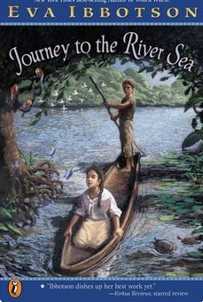  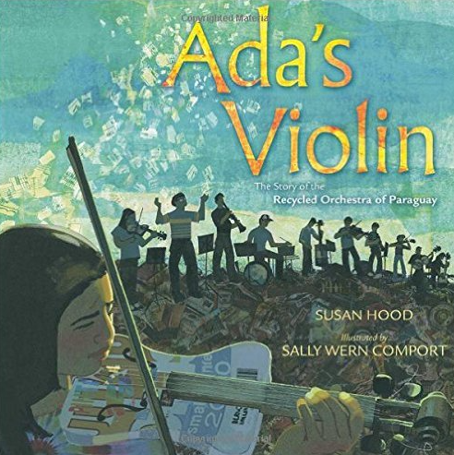  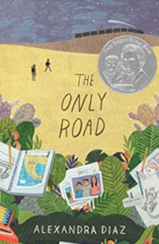  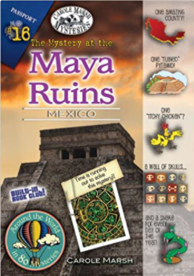  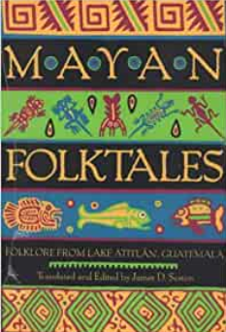  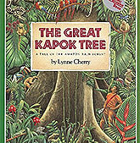  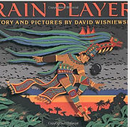  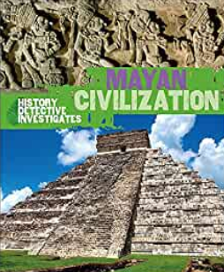 | English  - Explanation  - Persuasive writing  - Narrative  - Poetry | Spoken Language:  - listen and respond appropriately to adults and their peers  - ask relevant questions to extend their understanding and knowledge  - use relevant strategies to build their vocabulary  - articulate and justify answers, arguments and opinions  - give well-structured descriptions, explanations and narratives for different purposes, including for expressing feelings.  - maintain attention and participate actively in collaborative conversations, staying on topic and initiating and responding to comments  - use spoken language to develop understanding through speculating, hypothesising, imagining and exploring ideas  - speak audibly and fluently with an increasing command of Standard English  - participate in discussions, presentations, performances, roleplay/improvisations and debates  - gain, maintain and monitor the interest of the listener(s)  - consider and evaluate different viewpoints, attending to and building on the contributions of others  - select and use appropriate registers for effective communication  Reading:  Word Reading:  - apply their growing knowledge of root words, prefixes and suffixes (morphology and etymology), both to read aloud and to understand the meaning of new words that they meet.  Comprehension:  maintain positive attitudes to reading and an understanding of what they read by:  - continuing to read and discuss an increasingly wide range of fiction, poetry, plays, non-fiction and reference books or textbooks  - reading books that are structured in different ways and reading for a range of purposes  - increasing their familiarity with a wide range of books, including myths, legends and traditional stories, modern fiction, fiction from our literary heritage, and books from other cultures and traditions  - recommending books that they have read to their peers, giving reasons for their choices  - identifying and discussing themes and conventions in and across a wide range of writing  - making comparisons within and across books  - learning a wider range of poetry by heart  - preparing poems and plays to read aloud and to perform, showing understanding through intonation, tone and volume so that the meaning is clear to an audience  Understand what they read by:  - checking that the book makes sense to them, discussing their understanding and exploring the meaning of words in context  - asking questions to improve their understanding  - drawing inferences such as inferring characters' feelings, thoughts and motives from their actions, and justifying inferences with evidence  - predicting what might happen from details stated and implied  - summarising the main ideas drawn from more than 1 paragraph, identifying key details that support the main ideas  - identifying how language, structure and presentation contribute to meaning  - discuss and evaluate how authors use language, including figurative language, considering the impact on the reader  - distinguish between statements of fact and opinion  - retrieve, record and present information from non-fiction  - participate in discussions about books that are read to them and those they can read for themselves, building on their own and others’ ideas and challenging views courteously  - explain and discuss their understanding of what they have read, including through formal presentations and debates, maintaining a focus on the topic and using notes where necessary  - provide reasoned justifications for their views.  Writing:  Spelling:  - use further prefixes and suffixes and understand the guidance for adding them  - spell some words with ‘silent’ letters  - continue to distinguish between homophones and other words which are often confused  - use knowledge of morphology and etymology in spelling and understand that the spelling of some words needs to be learnt specifically.  - use dictionaries to check the spelling and meaning of words  - use the first 3 or 4 letters of a word to check spelling, meaning or both of these in a dictionary  - use a thesaurus  Handwriting and Presentation:  Pupils should be taught to write legibly , fluently and with increasing speed by:  - choosing which shape of a letter to use when given choices and deciding whether or not to join specific letters  Composition:  Plan their writing by:  - identifying the audience for and purpose of the writing, selecting the appropriate form and using other similar writing as models for their own  - noting and developing initial ideas, drawing on reading and research where necessary  - in writing narratives, considering how authors have developed characters and settings in what pupils have read, listened to or seen performed  Draft and write by:  - selecting appropriate grammar and vocabulary, understanding how such choices can change and enhance meaning  - in narratives, describing settings, characters and atmosphere and integrating dialogue to convey character and advance the action  - précising longer passages  - using a wide range of devices to build cohesion within and across paragraphs  - using further organisational and presentational devices to structure text and to guide the reader  Evaluate and edit by:  - assessing the effectiveness of their own and others’ writing  - proposing changes to vocabulary, grammar and punctuation to enhance effects and clarify meaning  - ensuring the consistent and correct use of tense throughout a piece of writing  - ensuring correct subject and verb agreement when using singular and plural, distinguishing between the language of speech and writing and choosing the appropriate register  - proofread for spelling and punctuation errors  - perform their own compositions, using appropriate intonation, volume, and movement so that meaning is clear.  Vocabulary, grammar & punctuation:  - recognising vocabulary and structures that are appropriate for formal speech and writing, including subjunctive forms  - using passive verbs to affect the presentation of information in a sentence  - using the perfect form of verbs to mark relationships of time and cause  - using expanded noun phrases to convey complicated information concisely  - using modal verbs or adverbs to indicate degrees of possibility  - using relative clauses beginning with who, which, where, when, whose, that or with an implied (ie omitted) relative pronoun  Indicate grammatical and other features by:  - using commas to clarify meaning or avoid ambiguity in writing  - using hyphens to avoid ambiguity  - using brackets, dashes or commas to indicate parenthesis  - using semicolons, colons or dashes to mark boundaries between independent clauses  - using a colon to introduce a list  - punctuating bullet points consistently | Drama:  - role-play  - hot-seating  - freeze frames  Pyjamarama  Sustrans Big Pedal  STAR project  Crucial Crew visit  First Aid Training  VR experience South America  Whole School Mosaic competition.  Summer Fayre  Charitable fund raising – class appeal  Cooking
 | Maths (White Rose)  - Ratio  - Proportion  - Statistics  - Properties of Shape  - Fractions (adding and subtracting, simplifying)  - Perimeter and area | - Arithmetic  - Fluency  - Problem solving  - Reasoning
 | Science  Animals Including Humans:  - Sc6/2.2a identify and name the main parts of the human circulatory system, and describe the functions of the heart, blood vessels and blood  - Sc6/2.2b recognise the impact of diet, exercise, drugs and lifestyle on the way their bodies function  - Sc6/2.2c describe the ways in which nutrients and water are transported within animals, including humans.  Light:  - Sc6/4.1a recognise that light appears to travel in straight lines  - Sc6/4.1b use the idea that light travels in straight lines to explain that objects are seen because they give out or reflect light into the eye  - Sc6/4.1c explain that we see things because light travels from light sources to our eyes or from light sources to objects and then to our eyes  - Sc6/4.1d use the idea that light travels in straight lines to explain why shadows have the same shape as the objects that cast them | Working scientifically  - planning different types of scientific enquiries to answer questions, including recognising and controlling variables where necessary  - taking measurements, using a range of scientific equipment, with increasing accuracy and precision  - recording data and results of increasing complexity using scientific diagrams and labels, classification keys, tables, and bar and line graphs  - using test results to make predictions to set up further comparative and fair tests  - using simple models to describe scientific ideas  - reporting and presenting findings from enquiries, including conclusions, causal relationships and explanations of results, in oral and written forms such as displays and other presentations
 | History  Non-European Study – Mayan Civilization | - Find out where the ancient Mayan civilisation was, who they were and locate their civilisation on a timeline and map.  - Explore and understand religious beliefs for the ancient Mayans.  - Recognise, understand and use the Mayan number system.  - Explore artefacts and evidence of Mayan history.  - Investigate the lives of people living in ancient Mayan civilization.  - Consider the differences between ancient British History, and the history of the Mayan people.
 | Geography  South America  - locate the world’s countries, using maps to focus on South America  - Use maps, atlases and the internet to discover and name the countries within South America; the oceans around South America; identify the main rivers within South America America.  - Identify the differences in climate within South America and discuss why using knowledge of global location.  - Identify human a physical geography of South America.  - Consider differences /similarities between South America and Great Britain. | CC links to English/History  Mayan history and geographical location.  Using books such as ‘Mayan Folklore’, the Great Kapok Tree, Ada’s Violin, links to English and History.  Rainplayer, Ada’s Violin – links to Music curriculum..
 | Art – CC link to History/Geog/English  - Create sketchbooks to record their observations and use them to review and revisit ideas  - Learn about great artists in history – great designers – Christ the Redeemer in Rio De Janeiro – Paul Landowski.  - Sculpting faces – clay. | - Improve their mastery of art and design techniques, including drawing, painting and sculpture with a range of materials  - Explore the sculpting of faces using clay.  - Study examples of ancient Mayan craft such as weaving and murals.  - Design and paint a Mayan mural, mixing colour and using stylised detail.
 | DT – Cookery  CC,inks to History, Geography, English &Art  - Design and cook a South American dish using local ingredients for a particular type of customer. | Design  - use research and develop design criteria to inform the design of innovative, functional, appealing products that are fit for purpose, aimed at particular individuals or groups  - generate, develop, model and communicate their ideas through discussion, annotated sketches, cross-sectional and exploded diagrams, prototypes, pattern pieces and computer-aided design  Make  - select from and use a wider range of tools and equipment to perform practical tasks [for example, cutting, shaping, joining and finishing], accurately  - select from and use a wider range of materials and components, including construction materials, textiles and ingredients, according to their functional properties and aesthetic qualities  Evaluate  - investigate and analyse a range of existing products  - evaluate their ideas and products against their own design criteria and consider the views of others to improve their work  - understand how key events and individuals in design and technology have helped shape the world  Technical knowledge  - apply their understanding of how to strengthen, stiffen and reinforce more complex structures
 | Computing  Blogging – Purple Mash:  - To identify the purpose of writing blog and its key features.  - To plan the theme and content for blog and write the content.  - To consider the effect upon the audience of changing the visual properties of the blog.  - To understand the importance of regularly updating the content of a blog.  - To understand how to contribute to an existing blog.  - To understand how and why blog posts are approved by the teacher.  - To understand the importance of commenting on blogs.  Research:  - Use search technologies effectively, appreciate how results are selected and ranked, and be discerning in evaluating digital content  - Select, use and combine a variety of software (including internet services) on a range of digital devices to design and create a range of programs, systems and content that accomplish given goals, including collecting, analysing, evaluating and presenting data and information  Safety:  - Use technology safely, respectfully and responsibly; recognise acceptable/unacceptable behaviour; identify a range of ways to report concerns about content and contact. (Drip fed every lesson) | CC links to History  - Blogging as a Mayan  - Researching Mayan artefacts.  CC links to Geography:  - Researching using Googlemaps and websites to discover facts/ locations, etc.
PSHE
- Healthy and well being – Link to Science and STAR Project.
- Relationships – Link to STAR project.
- Living in the wider world – link to STAR project.
 | RE  Kingdom of God  - Pupils know that Jesus told many parables about the Kingdom of God and they can describe at least one in detail (the feast, the tenants in the vineyard, the unforgiving servant).  - Pupils know that many Christians believe that Jesus teaching suggests that there will be a future kingdom where God’s reign will be complete.  - Pupils know that many Christians try to extend the kingdom of God by challenging unjust social practice and by practising forgiveness.  - Pupils know the Lord’s Prayer and can explain how this describes the Kingdom of God  Islam:  - To understand the importance of the prophet.  - To know about the night journey and ascension of the prophet.  - To recall facts regarding Islamic belief, including the name of the Holy text and places of worship, pilgrimages - Mecca.  - To know about some Islamic religious festivals – Eid. | - Explain connections between biblical texts and the concept of the Kingdom of God.  - Consider different possible meanings for the biblical texts studied, showing awareness of different interpretations.  - Make clear connections between belief in the Kingdom of God and how Christians put their beliefs into practice in different ways, including in worship and in service to the community.  - Relate Christian teachings or beliefs about God’s Kingdom to the issues, problems and opportunities of their own lives and the life of their own community in the world today, offering insights about whether or not the world could or should learn from Christian ideas.
 | PE  - Indoor –  - Outdoor – | PE planning
 | Music  - play and perform in solo and ensemble contexts, using their voices and playing musical instruments with increasing accuracy, fluency, control and expression  - improvise and compose music for a range of purposes using the inter-related dimensions of music  - listen with attention to detail and recall sounds with increasing aural memory  - use and understand staff and other musical notations  - appreciate and understand a wide range of high-quality live and recorded music drawn from different traditions and from great composers and musicians  - develop an understanding of the history of music. | - Perform with control and awareness of what others are playing.  - Improvise (including call and response) within a group using 3 or 4 notes.  - Compose and perform melodies using three or four notes.  - Make creative use of the way sounds can be changed, organised and controlled - Garageband (Linked to IT).  - Create accompaniments for tunes using drones or melodic ostinato (riffs).  - Create (dotted) rhythmic patterns with awareness of timbre and duration. | Charanga  Glockenspiel

