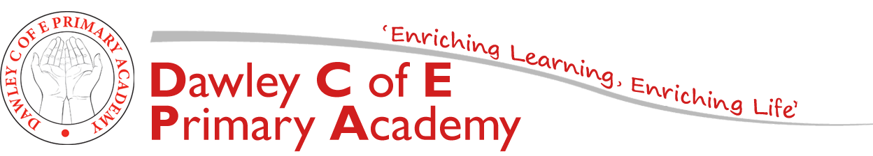
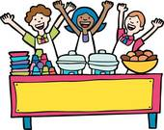

Year 1: Homework

Enjoy books and love reading
Year 1 pupils are expected to read at least 3 times a week and have it recorded in individual reading diaries. (This could be a school book, a book at home, magazine or comic). Children who read three times a week or more at home, will win a prize on Friday. Reading must be recorded in their reading diaries for them to win a prize.
Quicken mental maths skills
Children should practise number bonds to 10 (the two digits that add up to 10) and know that 9+1 = 10 so 1+9 =10. Familiarise your child with 2, 5 and 10 timetables.
Themed Homework Activities
The tasks cover a range of different areas of learning and vary in the level of adult input required. They are all based on our topic and will enhance the work we complete in class. The homework book is to be handed in at the end of this half term on Wednesday 14th July 2021 so that we can celebrate all homework completed so far. If you need any ideas/materials to complete any tasks, please ask. Thank you for your continued support.
Mrs Breeze
Task 1:  Phonics:  Keep practising phonics and read to an adult daily.  Write out the HFW’s, focus on using your best cursive handwriting style. Are you ascenders tall and descenders long? | Task 2:  Maths:  Practise your 2’s, 5’s and 10’s times tables.  Login to Numbots at least 3 times a week. Who will be our weekly top scorer? | Task 3:  Science:  Choose objects from around your home and draw them  What materials are they made from?
Task 4:  English:  Can you write a set of instructions for something you might do every day? It could be brushing your teeth or your bedtime routine.  Remember to include a title, what you will need list and a method (how you do it) | Summer 2 Topic  Come dine with me! | Task 5:  Design and Technology:  Help your adult to create a fruit salad or bake a cake together.  Think about the tools you are using and what they do.
Task 6:  RE:  Research Islam and why it is important to Muslims.  What are the similarities and differences to Christianity? | Task 7:  Reading:  Read part of your reading book. Predict what might happen next and write it in your homework book. | Task 8:  Geography:  Where is your favourite beach? Locate it on a map and tell me what I could see and do there.

